- Explain the difference between laminar and turbulent flow and the importance of this difference for sediment transport in rivers. (3 points)

honors & mc

- What is saltation?

maybe

- Draw a Atypical@ shape of the longitudinal profile of a stream between its headwaters and its mouth. What happens to average velocity of flow and average size of the particles on the streambed as we move downstream along this profile? (4 points)

use, two questions – second mc

- How are the A horizon and the B horizon in a soil different from each other? (4 points)
use, mc

- Draw a diagram illustrating the form of a meandering channel (i.e. looking down from above), and draw a line indicating the path followed by the thread of maximum flow velocity in the channel.

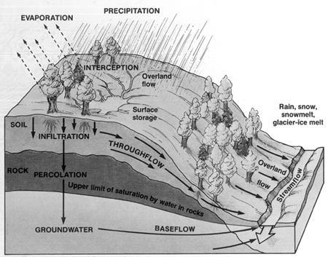

- What happens to most of the water that falls on the continents in any year? (i.e. which component of the hydrologic cycle accounts for most of the water)
- What is an aquifer?

- In the space below, draw a schematic diagram illustrating the hydrologic cycle on a typical hillslope and valley. Label each of the elements of the cycle.

- Explain the difference between actual and potential evapotranspiration. If you plot the annual cycle for both of these, under what conditions would actual be different from potential? (3 points)

- Explain what it means to say that a soil is at field capacity or at the wilting point.

- Which of the following statements is false?

a. much of the runoff in a stream is derived from seepage of groundwater into the bed of the stream
b. on islands and in coastal regions, fresh groundwater floats on top of denser saline groundwater
c. much of the water currently being extracted from the Ogallala aquifer has been in the aquifer for several hundred to several thousand years
d. pumping from a well may cause a local reversal of the hydraulic gradient, inducing groundwater flow toward the well
e. the velocity of groundwater flow almost always increases with depth beneath the earth’s surface

- The water-budget concept treats the soil as a system with inputs, outputs, and storage of moisture. The annual water budget shown below illustrates monthly variations for a typical humid midlatitude location. Based on discussions in class and your reading of the textbook, you should be able to identify which line represents which variable and interpret the graph. Which of the following statements is consistent with the pattern shown?
a. streamflow reaches its annual minimum in December
b. streamflow reaches its annual minimum in late September or early October
c. streamflow reaches its annual minimum in July or August
d. streamflow reaches its annual minimum in April
e. the graph doesn't provide sufficient information to determine when streamflow is likely to be lowest

- What is baseflow and where does it come from?

- We typically characterize soil profiles on the basis of a number of different kinds of properties. Color and texture are two of the most important. Name two other properties that may be considered useful in describing the soil and its horizons.

- How are braided streams different from meandering streams, and why do they look the way they do?

- How would you recognize the difference between a soil and a pile of loose sediment or rock debris at the earth’s surface? (4 points)

- For each of the Koppen climate types listed below, provide a brief description of the climate type and describe where on the globe you might find it. (2 points each)

Aw _______________________________________________________________________

_______________________________________________________________________

BWh___________________________________________________________________

_______________________________________________________________________

Cfb_____________________________________________________________________

________________________________________________________________________

- Explain the difference between the Cw and the Cs climate and the reason why the Cw climate appears to exist only in a region extending from China to north-central India. (3 points)

________________________________________________________________________

________________________________________________________________________

________________________________________________________________________

- Be prepared to identify the major climatic zones on a map of Africa.

- For each of the five major Koppen groups (A, B, C, D, E) provide a brief description indicating what the letter tells you and where in the world you are likely to find that group of climates.

