##### Versatile low-cost platform for optical detection of pH and dissolved oxygen

Neha Sardesai, Govind Rao, Yordan Kostov

Thu Feb 05 09:31:06 2015

The main bioprocess variables that are continuously measured are pH, dissolved oxygen (DO), dissolved carbon dioxide (DCO2), redox, concentrations of substrate and product concentrations, product activity, etc. Recently, pH and DO are measured using optical chemical sensors due to their small form factor and convenience in use. These sensors are typically interrogated using a lab grade spectrometer, or with the help of a low-cost, tailor-made opto-electronic transducer that is designed around the optical sensor. In this contribution, we are presenting a new class of opto-electronic transducers that are capable of monitoring several different optical sensors without the need to switch the optics or hardware when changing the type of sensor. This allows flexibility closer to the lab-grade devices at a price point of a dedicated sensor. This universal optical platform is capable of seamlessly switching between the pH and DO measurement modes and is capable of auto recognition of the sensor type. The principle of ratiometric fluorescence is used for pH measurements, and fluorescence lifetime for DO measurements. An approach to obtain identical calibrations between several devices is also presented. The described platform has been tested in actual bioprocesses and has been found adequate for continuous bioprocess monitoring. The low cost of the device allows for simultaneous use of several sensors for parallel monitoring of bioprocesses.

## 1 Introduction

The most commonly measured variables during any bioprocess are pH and dissolved oxygen (DO), either for monitoring or for the purpose of control. Measurements are performed using the traditional electrochemical sensor [1] or, more recently, using optical sensors [3 and many more.]. The latter are prized for their small form factor and the possibility for performing minimally invasive measurements. In particular, the use of pH and oxygen sensing patches makes it possible to monitor any transparent vessel externally [3].

These sensing patches comprise of fluorescent dyes sensitive to the respective parameter (pH and DO), that are immobilized in a matrix to form a chemical patch sensor [4]. These patch sensors are typically interrogated using a specialized spectrometer; this could be a general lab-grade spectrometer outfitted with fiber optics [5], a fiber-based spectrometer [5] equipped with a proper light source, or with the help of a tailor-made photometer that is designed specifically to read data from the chemical patch sensor [2].

These tailor-made photometers are low-cost, and are capable of monitoring a number of processes, or a number of spatial points in the same process. Such a custom-made opto-electronic photometer along with the chemical patch sensor is often called an optical sensor.

One of the main issues discussed in this paper is that of standardization of the optical sensor. The chemistry of the patch sensors has made great strides and has made it possible, to produce batches of sensing patches that are practically identical [5]. However, the same has yet to be achieved for the low-cost photometers. The main reason for this is the variability of the light emitting diodes (LEDs) that are used as light sources. While the light intensity, turn-on voltage, and response time of an individual LED are fairly constant within the short periods of time of their continuous use (days to several weeks during a standard bioprocess),the same cannot be said when several LEDs are to be compared. For example, even within the same batch of LEDs, the intensity can vary up to 50% [10]. There are also some variations in the emission spectrum of the LEDs. Therefore, there is a need for a standardization procedure for the opto-electronics part of the optical sensor.

This paper describes the design and implementation of a smart opto-electronic transducer intended to be used either with pH or with DO sensing patches. This universal optical platform is capable of automatically detecting what type of a patch (pH or DO) is in use and it adjusts the detection algorithms accordingly. Furthermore, the system is designed so as to be usable with either patch-based or fiber-based sensors. An approach to calibrate several devices so that they produce the same readout from the same chemical sensor is presented.

A two-channel version of the sensor was extensively tested in combination with commercially available pH and oxygen sensitive patches. The measurement accuracy of the system was 0.08 pH units and approximately 1% at low oxygen concentrations. The system was used for monitoring of *E. coli* fermentation.

## 2 Theory

This section discusses the concepts behind the design of the pH and Dissolved Oxygen (DO) patches, and the calibration of the sensor for the patches.

#### 2.1.1 pH fluorescent sensor sensor

The pH of a solution is given by the negative logarithm of the hydrogen ion concentration in the solution and can be measured using indicators. In this system, a fluorescent indicator 1,8-dihydroxy-3,6-pyrene disulfonic acid disodium salt (DHDS) is immobilized in a cross-linked polyethylene glycol hydrogel matrix with suitable optical and diffusion properties [11]. The hydrogel is optically transparent while presenting only minimal diffusion barrier to Hydrogen ions. DHDS exhibits two excitation wavelengths, one in violet () corresponding to acidic form, and the other in blue () corresponding to its basic form. The ratio of emission intensities, R, for these two wavelengths is related to the proton concentration according to [6],

 (1)

where  and  are the ratios for the acid (HA) and conjugate base (A-), respectively,  and  are the extinction coefficient and quantum yield of each species evaluated at , and  is the equilibrium dissociation constant [6]. Thus, the ratio of the intensities of the emissions is related to the pH in the solution in which the DHDS patch is placed. It should be noted that the transfer function is non-linear. This is the theoretical equation used for calibration.

#### 2.1.2 DO patch sensor

Optical detection of dissolved oxygen is achieved using quenching-based indicators [13]. In this work, an oxygen sensing patch with immobilized RuDPP (rhuthenium tris(diphenyl phenathroline) dichloride [12] was used. The dye is physically adsorbed on silica gel, which in turn is embedded in silicone rubber. The rubber is an optically transparent matrix, which allows for easy passage of gases due to its high diffusion constant. However, it is extremely hydrophobic, which prevents the immobilized indicator from washing out.

RuDPP is a member of a well-known family of phosphorescence dyes, and in the presence of di-oxygen, dynamic quenching of its excited-state occurs [12]. The emission intensity  and the decay constant  in presence of molecular oxygen is given by Stern-Volmer equation,

 (2)

where  is emission intensity in the absence of oxygen,  is decay lifetime constant in the absence of oxygen,  is Stern-Volmer constant,  is quencher concentration [7]. As the decay constants do not depend on dye concentration, their values are most often used for oxygen determination. Equation 2 is the theoretical representation for calibration for the DO patch.

#### 2.1.3. Instrumentation Transfer Functions

Equations 1 and 2 represent the theoretical transfer functions of the chemical transducers which convert the chemical quantity into characteristics of light. However, an optical sensor consists of a chemical and optical transducer, which converts the light into electric signal. Therefore, the full transfer function of the instrument needs to be derived. Furthermore, as the system is capable of working with more than one chemical transducer, establishment of transfer functions for each case is required.

Most often, the fluorescence signal is measured in the presence of ambient light with an intensity that is orders of magnitude higher than the fluorescent signal itself. Furthermore, ambient light can have multiple components originating from sunlight, incandescent and/or fluorescent light bulbs, etc. The spectral content of these sources varies greatly. The intensity of incandescent lights is modulated at 100 or 120 Hz (double the AC line frequency depending on the country), while the intensity of the fluorescent lights with electronic ballast is typically modulated at approximately 45 kHz (double the switching frequency of the ballast, which is set above the audible range) [14]. Additionally, the excitation light can create interference that is coherent with the signal, and this interference can be both of optical origin (light leakage through the optical filters), or electromagnetic origin (inductive or capacitive coupling from the excitation LED into the photodetector). Thus, the signal-to-noise ratio (where noise is considered as all the unwanted signals) can be easily as low as 1:1000 or even lower.

To improve this signal-to-noise ratio of the final measurement, an approach that allows extracting the fluorescent signal from all this noise is used. Such an approach is known as lock-in detection, synchronous detection or stochastic resonance [15]. First, the intensity of the excitation light is modulated at a frequency that is distinctly different from the interference which results in modulation of the emission signal as well [16], [9]. The modulation of emission signal wrt excitation signal modulation is a property of fluorescence [9]. The amplitude of the emission signal  is

 (3)

where  is fluorescence decay rate of the fluorophore,  is modulation frequency of light,  is quantum yield, and  is the phase shift between the excitation and emissions. It can be derived that .

In case of pH measurements, the decay rate of the DHDS dye is in range of single nanoseconds. Modulating the excitation at 10 kHz would result in an emission also modulated at 10 kHz, with the denominator of (3) approximately being 1. Similarly,  and hence,  where  is a constant.

In the case of oxygen measurements, the fluorescence decay rate of the RuDPP dye varies between 1 and 5 microseconds. When the excitation light is modulated at 75 kHz, the occurring phase shift  is significant (up to 62 degrees). Therefore, finding the phase shift allows determining the decay rate  and hence, the oxygen concentration.

As the frequency of the signals is fairly low, their amplitude or phase are found by homodyning. The signal is multiplied by two instances of the excitation signal, one that has zero degree phase shift (), and one that has 90 degree phase shift (). These are given by the equations 4 and 5,

 (4)

 (5)

where  is the in-phase signal and  is the quadrature signal. This signal is then passed through a low pass filter [15] which results in,

 (6)

Let’s now consider pH measurements. As ,  and . Hence, ratio  for the IP values when exciting at two wavelengths is given by,

 (7)

Here,  is the ratio of emissions from equation 1 and  is the ratio of excitation amplitudes at two different wavelengths. This ratio must be constant to obtain reliable calibration.

The transfer function of the pH sensing optoelectronics is given by,

 (8)

Dissolved oxygen concentration measurements are derived from decay rate , which is proportional to . From equation 6, it follows that,

 (9)

Therefore, the transfer function of the system in the case of DO measurement is,

 (10)

### 2.2 Standardization of optoelectronics

The goal of standardization is to achieve the same measurement readout when the same chemical sensor is read using several different optoelectronic transducers. Furthermore, if the optoelectronics readout is equivalent to a lab-grade (i.e. properly corrected spectrally) fluorometer, the chemical sensors can be produced and qualified independent of the hardware used for their interrogation.

Lab grade fluorometers are standardized using excitation spectral corrections and emission spectral corrections. For excitation side correction, the measured fluorescence emission is normalized by the excitation intensity. In effect, the resultant emission is equivalent to excitation with white light [9], [18]. Emission side correction is usually also required due to changes in detector’s sensitivity with the wavelength.

In the presented optical system, the reading is always a ratio. When measuring pH, the emission spectrum is the same regardless of the excitation wavelength. When measuring DO, the in-phase and the quadrature components of the same emission are ratio-ed. Therefore, any spectral variation on the emission side are canceled out, and correction is not needed. However, excitation–side correction in for pH and phase correction for DO are still required.

### 2.3 pH standardization

In lab-grade fluorometers, the excitation source is typically a high-power broadband lamp. For excitation, the light is passed through a wavelength selection device (monochromator, narrow band-pass filter). A small potion (~4%) is diverted and quantified for normalization of the measurement. This is necessary due to the drifts of the lamp intensity due to temperature, aging, etc. However, it is technically challenging to add additional optics and detectors in the small form factor of a sensor. Furthermore, the excitation side correction for a lab grade fluorometer is computationally intense and beyond the capacity of a low power micro-controller typically used in sensors. Finally, the LED intensity - light source of choice in the small, low-cost optical systems - is significantly more stable as compared with a lamp.

With that in mind, we opted for correction by adjustment of the excitation LEDs intensity. Below we’ll discuss the theoretical base for such approach.

The intensity ’’ of a fluorophore when excited at a particular wavelength is given by,

 (11)

where,  is excitation intensity,  is intensity exiting the sample,  is the ratio of the average energy of emitting photons to that of the incident photons, and  is the quantum yield [8], [9].

Applying Beer-Lambert’s law, integrating over entire excitation bandwidth and approximating, we obtain the following expression for the fluorescence intensity *IF*

 (12)

where, andare functions describing dependence of excitation intensity and the extinction coefficient on the wavelength, and *S* and *L* are respectively the shortest and the longest wavelength in the excitation spectrum that contribute to the detected fluorescence emission. The values for the functions and the wavelengths are different, but constant for the both excitation systems. Therefore, the value of the integral in (12) is constant and the fluorescence intensity obtained by the use of LED excitation is proportional to the normalized intensity obtained using a lamp. Furthermore, the goal is to measure not just the intensity, but the ratio of intensities *R* when the transducer is excited at two different wavelengths (i.e. *1* and *2*). This ratio can be expressed by

 (13)

where *LED* and *lamp* superscripts denote the excitation light source. It should be noted that for the LED excitation, two different LEDs with the respective emission maxima are used. Also, *m1* and *m2* are the proportionality coefficients for the respective LEDs and the lamp. It follows from (13) that if we can vary the fluorescent intensity resulting from LEDs excitation, it should be possible to equalize the ratio read by the lab-grade and the LED-based fluorometers. This is easily done by changing the LED intensity via current adjustment while monitoring a fluorophore.

### 2.4 DO standardization

For DO mode, the sensors are excited and read at single wavelength; therefore, no emission or excitation side spectral correction is needed. However, it is still needed to correct for any additional phase shifts that are introduced by the electronics. Due to very high transimpedance amplification, analog amplifiers introduce significant phase shift in the measured signal. Therefore, a procedure to to measure and subtract the phase offset was developed. It relies on the use of “zero decay time constant” fluorophore. In essence, this is a fluorophore with a decay time that is 3 or more orders of magnitude shorter than the the sensing fluorophore, but with similar spectral characteristics. Assuming that the average phase shift of the sensing fluorophore is ~45°, it follows from (3) that the phase shift of a fluorophore with a decay constant that is 1000 times shorter will be less than 0.04°, which is below the detectionlimit of the electronics. Therefore, any observable phase shift with this fluorophore is resulting from the electronics and should be subtracted.

## 3 Description of the system

The sensor platform consists of the chemical sensors, optics, and optoelectronics. The output from the is sent to a computer for visualization.



Figure 2: Sensing foil on window and a sleeve

### 3.1. Chemical sensors

The pH or DO sensors [xx] are in the form of have a form factor of a thin foil comprising of sensing layer sandwiched between light shield and adhesive layer (Figure XX a). It can be used by directly attaching it on the inner surface of a vessel window and probing it externally. This approach works in cases where ample space is available for access of the optics to the window. In cases when the space is limited (small size vessels, lack of vessel windows, or presence of only small ports), the sensors are placed on the tip of a plastic optical fiber (Figure XX b). In order to ensure tight reusable coupling between the fiber and the patch, a “patch sleeve” was developed. The patch is attached to one side of a short silicone tubing using RTV silicone rubber. The tubing diameter is slightly smaller than the fiber’s jacket, ensuring that the patch stays in place due to the compression, while removing the possibility for the tested medium to enter the space between the fiber and the sensor foil.

### 

### Figure 3: Beam combiner/splitter setup

### 3.2 Optics

In the case when the system was used with optical fiber, 15 inch long single core optical fiber is used. One end was fit inside a stainless steel tubing with inner diameter equal to the outer diameter of the fiber (i.e. 3 mm). This piping helps steady the fiber while taking readings. On the other end, the fiber enters a plastic holder (Figure 3). The holder both keeps the fiber aligned with the incoming light and also holds the focusing lens. A half-ball lens with 5 mm diameter is used to focus the excitation light into the fiber and emitted light to the photo-detector. The fiber has a core width of 2 mm and with the sheath, it measures to a 3 mm diameter.

In order to perform ratiometric excitation, two LEDs with emission maxima at 405 (violet) and 465 nm (blue) are used. They need to illuminate the same area of the sensing foil so as to avoid differential bleaching. Therefore, a beam combiner/splitter is used to direct the light from the LEDs and to the photodetector.

As seen in Figure 3, the blue and violet LED light is combined into a single beam using a dichroic filter with a cut-off 430 nm (450FL07, Andover, NH, oriented at 45° incidence). The “red tail” of the LED emission is removed by passing the beam via colored glass short-pass filter (BG-24, Schott). Then, the beam is directed toward the fiber/window using a second dichroic mirror (475FD68, Andover, NH, oriented at 45° incidence). The mirror reflects the blue and the violet part of the spectrum while transmitting the red and the green one. The returning fluorescence (with peaks ~530 in the case of pH sensing or 610 in the case of oxygen sensing) passes through the dichroic and is additionally filtered using a long-pass filter (500FH90, Andover, NH).

### 3.3 Electronics

The electronics consists of 3 main blocs: LED drivers, lock-in photodetectors and system-on-a-chip controller (SOC). All three have separate power supplies to avoid synchronous pick-up of interference via power fluctuations. The LED drivers are powered with 4.75V to provide sufficient forward bias of the LEDs. The lock-in photodetection module is powered also by 4.75V to provide ±2.37V for the op amps. SOC runs on 3.3V. All the power is derived from USB, which also provides bidirectional communication with the main computer.

SOC

S

VCCS

B

VCCS

V

DTA

DIA

DLIA

Figure 4: Block diagram of the electronics. DTA – differential transimpedance amplifier, DIA – differential inverting amplifier, DLIA – differential lock-in amplifier, B – blue LED, V – violet LED, S – sensor optics and chemistry, VCCS – voltage controlled current source, SOC – system-on-a-chip

The LED drivers are modulated, voltage-controlled current sources with shut-down capability. As such, video op amp (OPA355, Texas Instruments) in current follower configuration was used (Figure XX). The resistive divider on the non-inverting input (R1, R2) scales the control voltage UC down to allow for fine control of the current through the LED. The capacitor C1 in parallel with the resistor to the ground smoothens the sharp transients and reduces the spurious content in the electromagnetic emissions. The current through the LED is given by the equation:

 (13)

The resolution of the current steps was 25 A. The drivers are able to produce highly repeatable intensity through the LEDs during a pulse, very high contrast ratio and the capability to completely turn off the LED emission when disabled. The maximum current amplitude was ~50 mA. The drivers were capable of modulation frequencies up to 6 MHz.

**+**

**_**

R1

R2

C1

LED

R3

UC

Figure 2 LED driver.

The lock-in photodetector utilizes a PIN photodiode (BPW32, Osram) connected to a differential transimpedance amplifier (pair of OPA 354, TI),. Differential amplifiers allow for doubling of the output amplitude or the bandwidth and are very efficient at suppressing common-mode interference. This is of great importance in miniaturized designs, where relatively high-current LED circuits are in very close proximity (7-8 mm) to the very-high-impedance inputs of the photodetectors. The bandwidth of the photodetector was~200 kHz.

Two-stage amplification was used. The second stage was capacitor-separated inverting amplifier. The frequency response of the stage was designed to remove of the DC light component as well as the ever-present 60 Hz light flicker. This allowed to avoid possible saturation of the detector under room-light illuminations. The output of the amplifiers was fed directly into a differential square-wave synchronous detector (Figure XX) that consists of discrete analog switches and third-order low-pass filter with cut-off frequency of 3 Hz. After the rectifier, the resulting DC voltage is proportional to the IP or QD as defined in section 2.1. The use of the discrete components allowed for the use of a relatively slow, low-power and low-cost system on a chip (MSP430F4270, Texas Instruments), which features 16-bit 8 MHz microcontroller with built in 16 bit timers, 16 bit analog-to-digital converter (ADC) and 12-bit digital-to-analog converter (DAC). The synchronous detector was directly controlled by the SOC’s timer. The on-chip DAC was used to set the LED brightness, while the ADC converter was used to monitor the output from the lock-in amplifier.

Clock

3rd order differential

LPF

UACin

UDCout

Figure 3. Synchronous rectifier.

The micro-controller is programmed to perform a number of tasks such as reading signal from photo-detector, controlling current in LEDs, turning specific LEDs *ON* and *OFF*, etc. A hexadecimal number is associated with each function the controller performs. This number is used by the visual interface to communicate with the board via a USB cable.

### 3.4 Firmware and Software Description

**3.4.1 Firmware**

The micro-controller is programmed to operate the sensor in a slave mode and never initiates the tasks. It handles three groups of tasks: testing, constants recording and measurements. Testing set of commands allows to verify the operation of the sensor peripherals, i.e. turning on and off the LEDs, switching between the in-phase and quadrature detection, or turning on and off the photodetector. The ability to save constants is necessary in order to adjust and remember the brightness levels of the LEDs, as well as to record the chemical sensor constants that would be later used for the actual calculation of the pH or DO. It is also recording the amplitude and phase offsets that would be subtracted from the final measurement. The measurement commands specify whether pH (amplitude measurement at two different wavelengths) or DO (in-phase and quadrature measurement on a single wavelength) will be performed. The device return either the raw measured voltages or the calculated values of pH/DO depending on the command. It receives the commands and returns the measurement data in byte format via USB-to-RS232 converter (FT232, FTDI inc.).

**3.4.2 Software**

The control software and the visual interface for the optical sensor is designed and implemented in *LabVIEW*. The interface is designed such that the user has the flexibility to manually change various settings for the sensor, for example, current supplied to LED, delay between samples taken when data is measured continuously, reading offsets and considering them while taking measurements, etc.

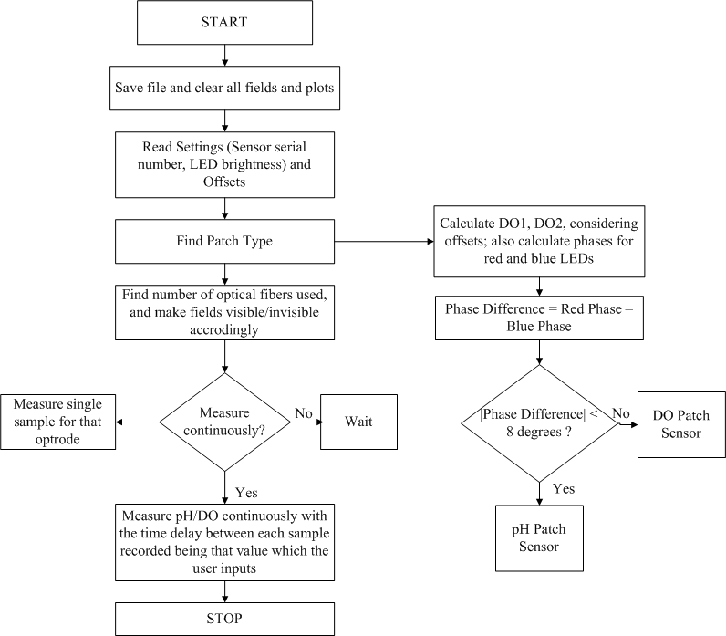 Figure 7: Flowchart describing the working of the visual interface

On start-up, the software performs several tasks on initialization (Figure XX). First, based on the voltage levels, it determines whether there is a sensor in front of the optics. If there is no sensor, the program can enter intensity mode which can be used measurement of the fluorescence of dissolved fluorophores. This allows the sensor to be used also for monitoring of the expression of fluorescent proteins.

If a sensor is detected (high amplitude levels) then the system determines whether this is a pH or DO sensor. The fluorescence decay rate of the pH indicator is approximately 1000 times shorter as compared the DO sensor. Therefore, the phase is measured; if it is significantly lower than the expected phase of the DO sensor in air, it is assumed that a pH sensor is present. Then, it is determined whether a single channel or dual channel device is being used; if this is a dual channel device, the process of identification of the sensor is performed for the second channel. The ability to use two channels is especially valuable when both pH and DO of a bioprocess have to be monitored simultaneously. In these cases, the auto-identification of the sensor is especially valuable, as the sensors are difficult to be identified visually due to their small size. The feature is aimed at prevention of possible mix-ups and loss of valuable data.

Once the sensors are identified, the software waits for action command. Typically, this is the start of the measurement; it is also possible to define where the data will be saved or to change the LED brightness. One measurement cycle take typically 1 second. It is possible to define longer intervals between the measurements to decrease the bleaching of the chemical sensor.

The performed measurements are displayed both in numerical form and graphically, allowing for direct monitoring of the process variables.

## Experimental results

The assembled sensor equipped with 2 optical fibers for simultaneous measurement of pH and DO is shown in Figure XX, a. The system allows monitoring in small vessels (i.e. test tubes, microwell plates, etc.) with diameter down to 10 mm. Used in a single fiber configuration, the system was successfully used to monitor a process in an Eppendorf tube. The visual interface with the controls for the measurement is shown in Figure XX, B.

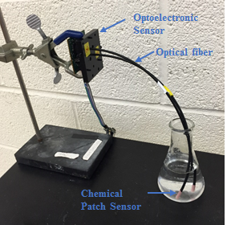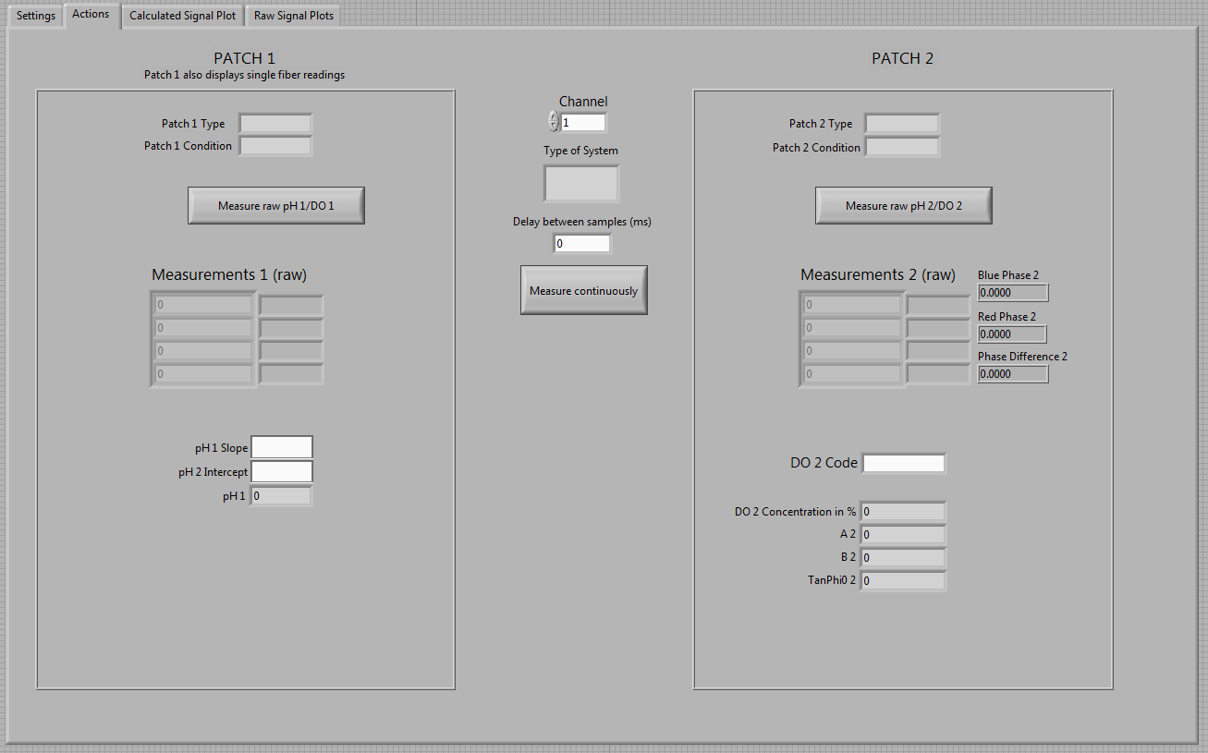

(a) (b)

Figure XX: (a) The complete optoelectronic system with chemical sensors measuring in a flask (b) The visual interface measuring pH and DO in the flask

### 4.1 pH mode standardization and calibration

Standardization of the sensors in pH mode was performed using a solution of 0.2 mg of HPTS (8-Hydroxypyrene-1,3,6-Trisulfonic Acid, Trisodium Salt, Aldrich) in 20 ml of deionized water. The pH of the solution was adjusted to 11 using NaOH. The ratio of the fluorescence intensities at 455/405 nm was measured on a lab fluorometer (Cary Eclipse, Varian) and was found to be 1.35. The solution was placed in a beaker and optical fibers (without the sensors) were positioned sideways to the beaker touching its wall. The beaker was placed on a black non-fluorescent surface (standard lab bench; if needed, a stand made of black ABS or Delrin can be used).

First, the fluorescence was excited using the 405nm LED. The measured voltage resulting from fluorescence was adjusted to be 50% of the ADC range by varying the intensity of the 405 nm LED. Then, the fluorescence was excited using the 460 nm LED. By changing its intensity, the ratio of the blue/violet intensities was adjusted to the same ratio as measured by the benchtop fluorometer. Four (4) different units were calibrated in this in this way – 3 single channel units and one dual channel unit. The achieved difference in the measured ratio was less than 1%. The values of the current for the required brightness is stored in the flash memory of the SOC.

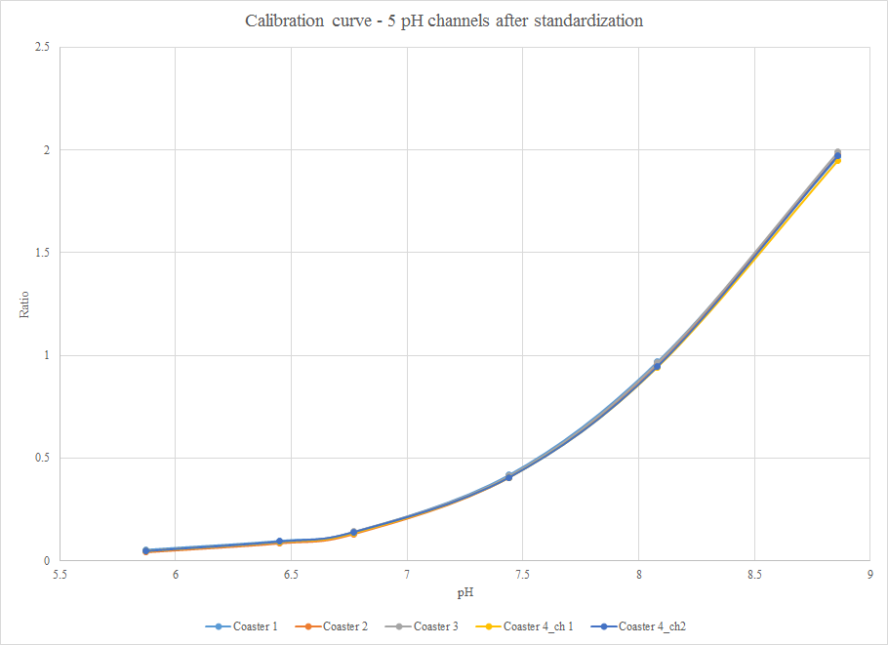

Figure XX: Standardization of pH patch

Next, the system with the pH sensors were calibrated using 6 different pH buffers: 5.87, 6.45, 6.77, 7.44, 8.08 and 8.86. Before the measurements, the sensors were hydrated in deionized water overnight at room temperature. The pH sensor was immersed in the buffer and the reading was recorded for a period of 10 minutes with an interval of 30 seconds between the measurements. The average value over these measurements was accepted as system reading. The results of the calibrated sensor systems are shown in figure XX. The standard deviation of the measurement within a single sensor channel was 2.61% at the lowest pH and gradually decreased to 0.15%. In the physiological range - pH 7.44 – the standard deviation of within a single device was 0.32%, which resulted in resolution of ~ 0.0037 pH for a single device with the use of the pre-calibrated patch. The confidence interval of the measurement was 6. When the same patch was used across all the devices, the standard deviation reached 3.06%. The bigger variation between the devices as compared with the standardization results was due to the differences in the patch positioning relatively to the light sources – we are using big diameter (2mm) optical fibers, and the size of the LED chip is ~ 0.5x0.5 mm. This results in somewhat uneven patch illumination from the LEDs. The bigger variation resulted in a resolution of 0.068 pH, again with confidence interval of 6. As resolution that is better than 0.1 pH unit is deemed sufficient for use in bioprocesses, this accuracy allows for use of any of the units in monitoring of fermentations and other bioprocesses.

### 4.2 DO mode standardization and calibration

The standardization in DO mode was performed using a solution of 1 mg Rhodamine B in 20 ml of water. The decay rate of Rhodamine B (1.68 ns) is three orders of magnitude shorter that the decay rate of the used oxygen sensitive dye (~5 microseconds in absence of O2). Therefore, the dye can be used as a fluorophore that will introduce 0° phase shift at the modulation frequency for the oxygen sensor (75 kHz). In fact, the phase shift it introduces at this frequency is below the resolution of our phase detector (0.04°, 6 confidence interval). Ends of the optical fibers (without the sensors) were positioned again touching the wall of a small beaker holding the dye solution. The resulting offset phase was recorded and subsequently subtracted from the measured phase of the optical sensor. The average phase offset of the boards was ~22°. The values of the offsets are stored in the memory of the SOC for subsequent use.

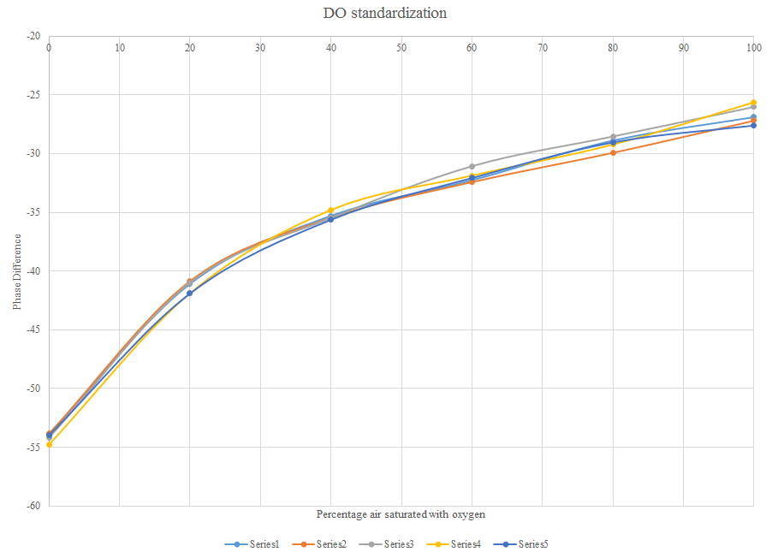

Figure 12: Standardization of DO patch

Next, the five channels of the systems were calibrated using the same DO sensor for DO percentages of 0%, 20%, 40%, 60%, 80%, and 100% of air saturation. The channels were tested in water that was saturated with the respective gas mixture obtained by mixing air and nitrogen. The percentages were set using the ratios of the flow rates in a dual flowmeter. The water solutions as well as the sensor were set in an incubator at 37Celsius in order to account for the temperature sensitivity of the oxygen dye. The solutions we also stirred to achieve faster equilibrium with the gas mixture. The data collection was started after the water-gas equilibrium was reached. Again, the data were collected for 10 minutes at 30 s intervals and the values were averaged. The calibration results are presented in Figure XX.

Considertions about the results…

## 4.3 *E. Coli* fermentation monitoring

To verify the ability of the sensor to operate under the conditions of an actual bioprocess, it was used to monitor pH and DO in an *E. coli* cell culture for 25 hours. The overnight seed culture consisted of a 0.5% (10 ) inoculum of *E. coli* strain BL21(DE3) frozen stock in LB media (Fisher Scientific, Catalog number MP113002142) incubated at 37C with shaking at 250 rpm [4]. The cell culture was then started in another flask by adding 10% seed culture to the media. Optical density value representative of the bacterial growth was measured offline with a Hewlett-Packard 8452A Diode Array spectrophotometer at 600 nm and was observed to be 0.343 for the passaging flask [4].

The optrodes are first sterilized with 70% ethanol. Then the patch sleeves are put on the probes. These sleeves are cleaned by dipping them completely in nuclease free water for 30 minutes. Since the optical probes would not read data properly with agitation or shaking, the cell culture was stirred using a magnetic stirrer. The probes were dipped in the culture such that the patches are completely submerged. The entire setup was placed in an incubator at 37C. Data for pH (on optrode 1) and DO (on optrode 2) was logged every 15 seconds.

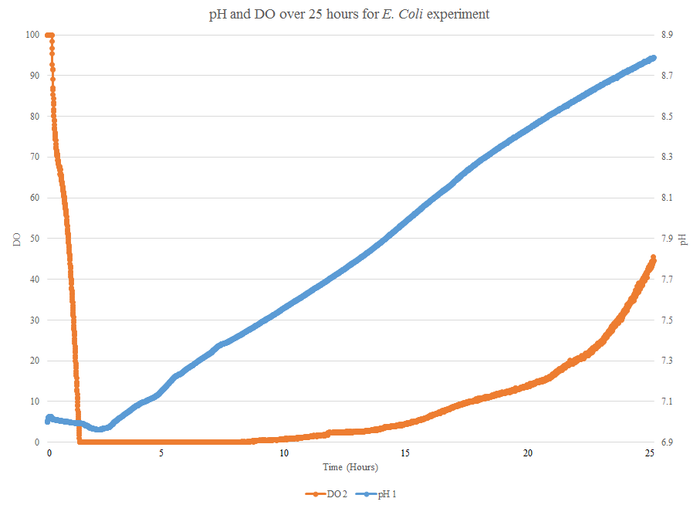

Figure 13: pH and DO profile for *E. Coli* over 25 hours

Figure 13 illustrate the profiles observed for pH and DO in the *E. Coli* cell culture over a period of 25 hours. The pattern of oxygen depletion during the exponential growth, as well as recovery of the DO to 100% at the end of the process are observed clearly with the optical sensor [4]. Thus, observed profiles when compared with the expected profiles are found to be similar verifying that the optical sensor functions efficiently.

## 8 Conclusion

The opto-electronic transducer and the chemical patch sensor together, comprise of the optical pH and DO sensor. This sensor is capable of detecting pH and DO within a range of 0.08 and 5% respectively. The sensor does not drift calibration wise for at least 15 hours. The visual interface is ’smart’ and is capable of detecting the type of system (single or dual fiber), the type of patch, whether patch is working or not, etc.

The theory of working of the chemical patch sensors is based on the opto-electronic transducer detecting the fluorescence generated due to each parameter. This leads to a discussion on the electronics and optics designed for the sensor. The visual interface provides user with an ease to communicate with, and manage the sensor.

Experiments conducted prove that the sensor is working not only in various buffers, but also in bioprocesses, like an *E. Coli* cell culture.

Thus, the sensor is a good substitute for other electro-chemical sensors since it is accurate, works over a long time, does not foul, and is comparatively cheaper. $150

**References**

[1] Michael A. Hanson, Xudong Ge, Yordan Kostov, Kurt A. Brorson, Antonio R. Moreira, and Govind Rao. Comparisons of optical ph and dissolved oxygen sensors with traditional electrochemical probes during mammalian cell culture.  *Biotechnology and Bioengineering*, 97(4):833–841, 2007.

[2] Yordan Kostov and Govind Rao. Low-cost device for ratiometric fluorescence measurements.  *Review of Scientific Instruments*, 70(12), 1999.

[3] Peter Harms, Yordan Kostov, and Govind Rao. Bioprocess monitoring.  *Current Opinion in Biotechnology*, 13(2):124 – 127, 2002.

[4] Yordan Kostov, Peter Harms, Lisa Randers-Eichhorn, and Govind Rao. Low-cost microbioreactor for high-throughput bioprocessing.  *Biotechnology and Bioengineering*, 72(3):346–352, feb 2001.

[5] Xudong Ge, Yordan Kostov, Leah Tolosa, and Govind Rao. Study on low-cost calibration-free ph sensing with disposable optical sensors.  *Analytica Chimica Acta*, 734(0):79 – 87, 2012.

[6] Peter Harms Haley R. Kermis, Yordan Kostov and Govind Rao. Dual excitation ratiometric fluorescent ph sensor for noninvasive bioprocess monitoring: Development and application.  *Biotechnology Progress*, 18(5):1047–053, 2002.

[7] Atul Gupta and Govind Rao. A study of oxygen transfer in shake flasks using a non-invasive oxygen sensor.  *Biotechnology and Bioengineering*, 84(3):351–358, 2003.

[8] Xudong Ge, Yordan Kostov, Leah Tolosa, and Govind Rao. Study on low-cost calibration-free ph sensing with disposable optical sensors.  *Analytica Chimica Acta*, 734(0):79 – 87, 2012.

[9] JosephR. Lakowicz, editor.  *Quenching of Fluorescence*, pages 277–330. Springer US, 2006.

[10] Philips. Custom luxeon design guide, 2006. Now discontinued.

[11] G. Rao, I. Kostov, H. Kermis, and P. Harms. Fluorescent dye comprising 6-methacryloyl-8-hydroxy-1,3-pyrene disulfonic acid for use in systems and methods which non-invasively and continuously monitor ph, April 28 2005. US Patent App. 10/609,720.

[12] Richard Carswell and Abdol R. Khoie. Optical oxygen sensor based on rudpp fluorescence quenching. volume 2705, pages 22–30, 1996.

[13] Xu-dong Wang and Otto S Wolfbeis. Optical methods for sensing and imaging oxygen: materials, spectroscopies and applications.  *Chemical Society Reviews*, 43(10):3666–3761, 2014.

[14] Charles L. Amick.  *FLuorescent Lighting Manual*. McGraw-Hill Book Company, 1942.

[15] M. L. Meade.  *Lock-in Amplifiers: Principles and Applications*. Peter Peregrinus Ltd on behalf of Institution of Electrical Engineers, 1983.

[16] Siyuan Fu, Atsunori Sakurai, Liang Liu, Fredrik Edman, TÃµnu Pullerits, Viktor Ã–wall, and Khadga Jung Karki. Generalized lock-in amplifier for precision measurement of high frequency signals.  *Review of Scientific Instruments*, 84(11), 2013.

[17] U. Schreiber, U. Schliwa, and W. Bilger. Continuous recording of photochemical and non-photochemical chlorophyll fluorescence quenching with a new type of modulation fluorometer.  *Photosynthesis Research*, 10(1-2):51–62, 1986.

[18] J.N. Miller. Correction of excitation and emission spectra. In J.N. Miller, editor,  *Standards in Flourescence Spectrometry*, volume 2 of  *Techniques in Visible and Ultraviolet Spectometry*, pages 49–67. Springer Netherlands, 1981.