Evaluation of global CO simulations: Uncertainty constraint by emissions, chemistry reactions, and transports

H. Bian¹, M.Chin², R.Kawa², B.Duncan¹, P.Kasibhatla³, A.Arellano⁴

Abstract

We present here a systematical evaluation of CO simulation with the recent findings in CO studies incorporated. The global CO for the year 2000-2001 are simulated with a unified chemistry transport model (UCTM), set up with our current ‘best’ knowledge in CO simulation and driven by the assimilated meteorological fields from NASA‘s Goddard Earth Observation System version 4 (GEOS_4). A series of sensitivity experiments, each with a particular variation of an input dataset, a parameterization, or a scheme, are conducted for the year 2000 to explore the sensitivities of global and regional atmospheric CO response to uncertainties in several important model processes such as emission, chemistry, and transport. We compare and contrast the sensitivity experiments with the standard simulation and with the measurements from satellite MOPITT instrument and surface and airborne CMDL network. The evaluation of the three a priori and two a posteriori biomass burning emissions indicates that the a posteriori emissions improve CO simulation generally; however, further investigations are needed for some regional anomaly, such as extremely high CO over Central America. The simulated CO fields also demonstrate that the systematic bias induced by different methodologies and data origins is more significant for biomass burning emission than its interannual variation between 2000 and 2001 on global scale. Comparing with MOPITT data, the simulated column CO’s outflow ability is too weak from Southeast Asia, which results in higher values over Asia’s biomass burning source region and its adjacent west Pacific but much lower over the rest of NH Pacific. Therefore, the conclusion of overestimated biomass burning emission in Asia regions proposed by TRACP-P campaign needs re-examination. Besides the usage of different biomass burning emission which could cause the largest regional CO variation, the CO simulation is very sensitive to convection transport, especially over active deep cloud regions such as tropical and NH summer. Our study also indicates that the usage of real time OH field is critical for CO simulation on the industrial influence regions due to the large OH interannual variation.

1. Introduction
Atmospheric CO has been extensively studied due to its important roles in atmospheric chemistry, air quality, and carbon research [Kanakidou et al., 1999]. CO is the dominate sink of atmospheric OH and plays a major role in tropospheric ozone production and destruction [Duncan et al., 2005], both are the main atmospheric oxidants. CO itself is one of the pollutant gases which directly affects human health and indirectly through alters tropospheric O₃ [Seinfeld, 1986; Chameides et al., 1994]. CO is a ubiquitous by-product of the same combustion processes as CO₂ and is a valuable tracer to distinguish anthropogenic from natural carbon fluxes [Schmitgen et al., 2004]. Combining CO and CO₂ studies should help to disaggregate carbon emissions from different regions and types whose CO₂/CO emission ratios are very different [Palmer et al., 2003; Schmitgen et al., 2004; Suntharalingam et al., 2005]. CO is of interest also because of its relatively simple chemistry and deposition process, and its lifetime enables it to be an ideal indicator for multiscale transport studies [Holloway et al., 2000; Allen et al., 2004].

Improvement of CO simulation is often driven by the improvement of emission estimates. Recent efforts in our understanding of CO emissions include global and regional improvements of fuel combustion and biomass burning using both bottom-up and top-down approaches. For example, Duncan et al. [2003] investigated interannual and seasonal variability of biomass burning emissions constrained by satellite observations from TOMS/ATSR/AVHRR. TRMM-based biomass burning emissions were obtained using the approach described by Randonson et al., [2003] and Van der Werf et al., [2003, 2004]. Two a posteriori emissions are also presented to improve global fuel combustion and biomass burning with the measurements from satellite MOPITT instrument [Arellane et al., 2004; 2005] and CMDL network [Arellane et al., 2005]. Because of the rapid economic development in the Asia region, intensive studies are conducted which intend to update Asia’s emissions. Street et al. [2003] summarized the statistical environment and energy data in Asia and gave an inventory of gaseous and primary aerosol emissions there in year 2000. An enhancement of around 40% to more than 200% of this recent bottom-up fuel combustion estimates is required to bring a better agreement between model and observations during TRACE-P campaign using top-down estimates [Heald et al., 2003; Palmer et al., 2003; Arellano et al., 2004] and statistical analyses [Carmichael et al., 2003; Allen et al., 2004; Tan et al., 2004]. In the meantime, a reduced biomass burning emission of about 40%-70% from Southeast Asia is proposed from TRACE-P studies [Heald et al., 2003; Palmer et al., 2003; Allen et al., 2004; Wang et al., 2004]. Model generated biogenic emissions are updated considering improved emission effects, leaf area and age, temperature, light, and canopy attenuation in the new inventory of model of emissions of gas and aerosols from nature (MEGAN) [Guenther and Wiedinmyer 2004]. Among emission uncertainties, biomass burning emission represents the largest daily-seasonal-annual variation and uncertainty for CO emissions. Despite recent improvements offered by new satellite products to determine the timing and location of fires, quantifying fire emissions across large spatial scales still suffers from large uncertainties, mainly due to uncertainties in fuel loads, combustion completeness, and burned area [Randonson et al., 2003]. Other uncertainties in CO simulation involve in the parameterization of chemistry, the dynamical transport error, and the possible balanced budgets between dry deposition and the degradation of plant matter.
We present here a systematical evaluation of CO simulation with the recent achievements incorporated. This work is not an attempt to reproduce the actual CO observed concentration. Instead, we are interested in exploring the sensitivity of simulated atmospheric CO response to the uncertainties in important processes such as emission, chemistry reaction, and transport. We emphasize the evaluation of biomass burning emission by comparing and contrasting CO fields impacted by five emission inventories derived from the two origins, those based on TOMS/ATSR/AVHRR proposed by Duncan et al., [2003] and those based on TRMM/ATSR/AVHRR/MODIS proposed by Randonson et al., [2003] and van der Werf et al., [2003, 2004]. By establishing a general understanding of how sensitively simulated CO distribution responds to the uncertainties, we could better target the potential problems in resolving the CO simulation. To perform the investigation, we set up a standard simulation with our current ‘best’ knowledge about CO simulation, and then conduct a series of sensitivity experiments, each with a particular variation of an input dataset, a parameterization, or a scheme. The values and algorithms used in these sensitivity studies are not arbitrarily selected. They either have common applications (such as different biomass burning emissions and convection transport schemes) or change within described uncertainty (such as CO yield from CH₄ oxidation). They are selected in order to reveal the importance of interesting regulators in CO simulation, for instance, how variations of atmospheric CO are inferred from biomass burning inventories.

We organize this paper as follows. Model framework and the features of measurements are described in section 2.1 and 2.2 respectively. The conditions for the standard simulation and the ‘tested’ strategies are explained in section 3. We present and discuss how simulated CO distributions respond to the uncertainties in biomass burning emissions in section 3.1 and in the other emissions, chemistry reactions, and transports in section 3.2. Two year simulation with the standard settings is introduced in section 3.3 to address the importance of using timing OH field in CO simulation. Conclusions and implications of this work are presented in section 4.

2. Model and Measurements
2.1 Model description
The GSFC unified chemistry transport model (UCTM) evolved from two established global models: trace gas transport model (PCTM) [Kawa et al 2004] and Goddard chemistry aerosol radiation and transport model (GOCART) [Chin et al. 2002, 2004]. This off-line chemistry transport model intends to accommodate both gas and aerosol chemistry and is driven by analyzed meteorological fields of NASA’s Goddard Earth Observation System, Version 4 (GEOS-4) data assimilation system (DAS), updated meteorological fields every 3 hours. The spatial resolution of the UCTM used in this study is 2 degree latitude by 2.5 degree longitude by 25 vertical layers with the same 17 tropospheric layers as in GEOS’s.
The important physical and chemical processes for CO simulation are transport, emission, and chemistry. The dry deposition of CO due to its uptake by microorganisms is not accounted in this study since this pathway is uncertain and likely counterbalanced to some degree by the degradation of plant matter [Duncan et al., 2005]. The advection and diffusion algorithms of UCTM, same transport core as GOCART [Chin et al., 2002, 2004] and PCTM [Kawa et al., 2004], have been extensively evaluated [Lin and Rood, 1996, Li et al., 2002, Douglass et al., 2003]. Convection algorithm, which is designed to be consistent with the deep convection scheme [Zhang and McFanlar, 1995] and shallow cloud scheme [Heck, 1994] used in the fvGCM, has been evaluated in a recent CO₂ study [Bian et al., 2005].
Atmospheric CO is released directly from fossil fuel, biofuel, and biomass burning. The base CO inventory in Asia for both fossil fuel and biofuel is compiled by Streets et al., [2003]. The base CO inventory for the rest of the world is taken from the compilation of Duncan et al., [2005] for fossil fuel and Yevich and Logan [2003] for biofuel. These emissions are compiled on the annual mean basis. Seasonal variation is imposed on the annual mean CO fossil fuel emission, which is 7.2% higher than the annual mean in winter and 7.2% lower in summer, because the efficiency of emission control devices is temperature dependent [Stump et al., 1989; Duncan et al., 2005]. No seasonal variation is applied to biofuel emission. The improvement of the base CO fossil fuel and biofuel inventories is obtained based on the new findings of enhanced anthropogenic emission, ranging from 43% to more than 200% [Carmichael et al., 2003; Palmer et al., 2003; Heald et al., 2003; Allen et al., 2004; Arellano et al., 2004; Tan et al., 2004], in Asia regions proposed by recent studies for TRACP-P campaign with forward and inverse modeling. We adopt an Asia anthropogenic emission increase of 59% in this study.
Our standard simulation takes a posteriori biomass burning emissions based on the TRMM inventory but is constrained by MOPITT observations [van der Werf et al., 2004; Arellano et al., 2005]. TRMM-based inventory for 2000-2001 was constructed using the approaches described in Van der Werf et al., [2003, 2004] and Randonson et al., [2003]. The dataset is integrated using TRMM-VIRS hot spot data and burned area, updated with MODIS burned area for Africa, South America, and Australia, and extended spatially and temporally using ATSR and AVHRR data. The last improvement by relating ATSR fire counts to burned areas using a single scalar value for the extratropics and the whole time period enables emission to be able to determine monthly and interannual variability.
Atmospheric CO also comes indirectly through the oxidation of NMHC with anthropogenic and biogenic origin [Kanakindou and Crutzen, 1999; Granier et al., 2000; Duncan et al., 2005]. Duncan et al., [2005] studied CO from anthropogenic NMHC by multiplying the emission rate of each NMHC in a given inventory by a yield of CO per carbon atom oxidized (α_{NMHC}) and proposed the amounts equivalent to 20%, 19%, and 11% of the direct CO emission from fossil fuel, biofuel, and biomass burning, respectively. We pre-process the resulting CO from NMHC oxidation using these scaling factors and release them as the sources from the surface. Biogenic emissions of isoprene, terpene, and other NMHC can also be converted to atmospheric CO. The emissions of biogenic NMHC are adopted from GEIA inventory proposed by Guenther et al., [1995], but globally down scaled isoprene by 25% to maintain the resulting CO budget from isoprene as 175.7 Tg CO/yr and from global total biogenic NMHC as 353 Tg CO/yr, to be consistent with recent studies in literature [Palmer et al., 2003; Duncan et al., 2005]. GEIA’s biogenic NMHC consists of isoprene, terpene, and other NMHC. We apply the yields of CO as 0.2 for isoprene [Duncan et al., 2005], 0.2 for terpene [Hatakeyama et al., 1991; Vinckier et al., 1998], and 0.2 for the other NMHC. Releasing oxidized CO from NMHC on the surface instead of in the atmosphere will induce bias in atmospheric CO distribution. Oxidized CO from NMHC occupies approximately 25% of the total CO emissions. The bias due to nonrealistic source altitude depends on how rapid the oxidation of NMHC takes place. Further quantification of this effect is needed, such as the similar work for reduced CO₂ study done by Suntharalingam et al., [2005]. The total direct and indirect CO emissions from each category are summarized in Table 1.

Table 1. CO emissions for the standard simulation and the sensitivity experiments
 |  | Direct emission | Photochemical oxidation | References
Fossil fuel |  | 312.2 | 62.4 | Street et al., [2003]; Palmer et al., [2003];  Duncan et al., [2005]
biofuel |  | 166.4 | 31.6 | Yevich and Logan [2003]; Street et al., [2003];  Palmer et al., [2003]
Biomass  burning | BB01  BB02  BB03  BB04  BB05 | 395.0  429.8  464.7  516.8  415.9 | 43.5  47.3  51.1  56.8  45.7 | Duncan et al., 2003  Duncan et al., 2003  Randonson et al., [2003];Van der Werf et al., [2003]  Van der Werf et l., [2004]; Arellano et al., [2005]  Van der Werf et l., [2004]; Arellano et al., [2005]
Biosphere  (GEIA) | Isoprene  Terpene  Other NMHC |  | 175.7  59.5  117.8 | Guenther et al., [1995]
Biosphere  (fvGCM) | Isoprene  Monoterpene  methanol |  | 176.6  50.1  87.4 | Wang et al., [1998]; Duncan et al., [2005]
CH4 oxidation |  |  | 789.2 | DeMore et al., 1997
total |  | 873.6 – 995.4 | 1240.7 – 1293.0

CO is also produced by the chemical reaction of CH₄ in the atmosphere. CH₄ field is summarized from the long-term CMDL GLOBELVIEW-CH₄ observations [http://www.cmdl.noaa.gov/ccgg/globalview/index.html]. It is a 1-D monthly fields varying along latitude. The yield of CO per molecules of CH₄ is assumed as 1.0 throughout the troposphere for both high- and low-NO_{x} chemical environments as suggested by Duncan et al., [2005] in our standard simulation.
The only CO sink of this study is the reaction with atmospheric OH. UCTM adopts a pre-prescribed monthly mean OH field which combines GEOS-CHEM tropospheric full chemistry OH field for 2001[Bey et al., 2001; Park et al., 2004] and GMI stratospheric OH field for 1995. Tropospheric OH fields have included the effects of aerosols. Table 2 gives the global mean OH (molecular/cm³) and the lifetime of CH₃CCL₃ (τ) pertaining to the tropospheric OH only and to the all sinks including ocean and stratosphere. The lifetime of CH₃CCL₃ from recent measurements and other model are also listed in the table for comparison. The OH field used in this study closes to the low end of the measurements. However, the SH OH field is about 10% lower compared to that used in Duncan et al., [2005]. We will conduct a sensitivity test by increasing SH OH discussed in section 3.2 and the corresponding OH field is also listed in Table 2.

Table 2. Global mean OH concentrations and lifetime of CH₃CCL₃ in the total atmosphere and for tropospheric OH only from measurements and model datasets
τ (All sinks)  (years) | τ (Trop. OH)  (years) |  |  | Mean OH  (10⁵ molecular/cm³⁾ | References
Global | global | SH | NH | global
4.9 (+0.6, -0.5) | 6.0 (+0.95, -0.7) |  |  | 9.7 ± 0.6 | Prinn et al., 2001
4.6 | 5.7 |  |  | 11.6 | Spivakovsky et al., 2000
4.3 – 4.6 | 5.3 – 5.7 | 5.2 – 5.4 | 5.4 – 6.0 | 9.3 | Duncan et al., 2005
4.5 | 5.6 | 5.9 | 5.4 | 9.96 | This work, standard
4.5 | 5.5 | 5.6 | 5.2 | 10.18 | This work, tested

2.2 Observational data
The observational data of atmospheric CO mixing ratio is obtained, as the same source as CO₂’s [Bian et al., 2005], from NOAA Climate Monitoring and Diagnostics Laboratory (CMDL) Carbon Cycle Greenhouse Gases (CCGG) [http://www.cmdl.noaa.gov/ccgg/index.html]. Sampling frequencies are approximately weekly at local noon for surface (non-baseline) fixed sites and usually one to two times per month in local afternoon for aircraft measurement over aircraft sampling sites. Flagged data is excluded from our comparisons.
The retrieved satellite MOPITT CO is available since April 2000. The retrieval algorithm adopts a methodology named maximum a posteriori, which seeks the solution most statistically consistent with both the measured radiances and the typical observed patterns of CO profiles variability [Pan et al., 1998]. We use level 2 version 3 products which provide CO mixing ratios at seven standard vertical layers with 22 km horizontal resolution, 4 km vertical resolution, and about 10% precision. The total CO column also has roughly 10% precision.
The potential differences in model-observation comparisons due to the inherited features of spatial and temporal resolutions in simulation and model data have been discussed for CO₂ study in Bian et al., [2005]. Since the representation error is related to the heterogeneity of a tracer distribution within the grid, we expect a higher representation error for CO than for CO₂ simulated distribution.

3. Results and Discussions
A standard simulation and a series sensitivity experiments are conduced to investigate the sensitivity of global and regional atmospheric CO response to uncertainties in important processes such as emission, chemistry, and transport. Table 3 lists the main features in our standard simulation and in the sensitivity studies. Quantitative assessment of differences between the model results and observations over multiple temporal and spatial scales is also performed through calculations of statistical standards including correlation, mean bias, and root mean square.

Table 3. The main features in standard simulation and the ‘tested’ strategies.
standard | source | std  or  bbmsf | Fossil fuel – compiled by Duncan et al., [2005] except Asia region using Streets et al., [2003] with inversion adjustment by Palmer et al., [2003]
standard | source | std  or  bbmsf | Biofuel – compiled by Yevich and Logan [2003] and adjusted in Asia region as the same way as for fossil fuel emission
standard | source | std  or  bbmsf | Biomass burning – TRMM (see exp43) plus Scaling Factor obtained in inversion using MOPITT [van der Werf et al., 2004; Arellano et al., 2005]
standard | source | std  or  bbmsf | Oxidation – photochemical oxidation of NMHC from fossil fuel, biofuel, and biomass burning [Duncan et al., 2005]
standard | source | std  or  bbmsf | Biogenic – GEIA 1995 but globally decreased by 25% for isoprene constrained by recent research [Guenther et al., 1995, Duncan et al., 2005]
standard | chemistry | std  or  bbmsf | OH – GEOS-CHEM full chemistry model output for 2001for troposphere [Bey et al., 2001; Park et al., 2004]; GMI output for 1995 for stratosphere
standard | chemistry | std  or  bbmsf | CH₄ distribution is summarized from long-term CMDL GLOBALVIEW-CH₄ [http://www.cmdl.noaa.gov/ccgg/globalview/index.html]. Yield of CO from CH₄ is 1.0 [Duncan et al., 2005]
standard | transport | std  or  bbmsf | Advection – TPCORE
standard | transport | std  or  bbmsf | Convection – deep convection from Zhang and McFarlane [1995] and shallow from Heck [1994]
standard | transport | std  or  bbmsf | Diffusion – solve for diffusion equation
‘tested’ strategies | biomass burning | bbhvd | 2000 emission estimated based on TOMS AI/ATSR fire counts [Duncan et al., [2003]
‘tested’ strategies | biomass burning | bbclm | Climatological emission compiled by Duncan et al., [2003] using fire counts from ATSR (Aug. 1996 – Jul. 2000) and AVHRR (1-2 years during 1992-1994), and Aerosol Index from TOMS (1979 – mid 1993, mid 1996 – 2002)
‘tested’ strategies | biomass burning | bbtrm | TRMM based emission - compiled from TRMM-VIRS, MODIS, ATSR, AVHRR for 2000-2001. Approach is described in van der Werf et al., [2003, 2004], Randerson et al., [2003].
‘tested’ strategies | biomass burning | bbcsf | TRMM plus Scaling Factor constrained by CMDL [van der Werf et al., 2004; Arellano et al., 2005]
‘tested’ strategies | biogenic | tbio | Calculated by fvGCM with the algorithm proposed by Wang et al., [1998]
‘tested’ strategies | fossil fuel | tff | Double seasonality
‘tested’ strategies | OH | toh | Linear increase southern hemisphere OH from 0 (equator) to 20% (south pole) [Mauldin et al., 1999, 2004]
‘tested’ strategies | CO yield from CH₄ oxidation | tch4 | 0.9 [Tie et al., 1992, Arellano et al., 2004]
‘tested’ strategies | convection | tconv | A semi-implicit convection module, constrained by the subgrid-scale cloud mass flux [Kawa, et al., 2004]

3.1 Discuss the effect of biomass burning emissions
We examine three referred a priori satellite-based biomass burning emissions in CO simulations [see Table 1]. They are TRMM/MODIS/ATSR/AVHRR-based inventory for 2000-2001 (denoted as bbtrm) [van der Werf et al., 2003, Randerson et al., 2003], TOMS/ATSR-based for 2000 (bbhvd) and TOMS/AVHRR/ATSR-based climatology (bbclm) [Duncan et al., 2003]. We also evaluate two a posteriori biomass burning emissions based on the TRMM inventory but constrained by MOPITT (bbmsf) and CMDL (bbcsf) observations [van der Werf et al., 2004, Arellano et al., 2005]. Figure 1 summarizes the monthly mean biomass burning emissions from these five approaches on seven regions. Total global annual emissions have an uncertainty of 30% among approaches. However, their magnitudes of the peak emissions on each region differ substantially with typically more than double between low and high ones. The differences among the emission amounts are particular large in Central America’s spring season, and the two a posteriori emissions are about four times higher than the three a priori emissions. Generally speaking, these five approaches distribute the similar global annual emissions with different weightings to a region and further distribute the emission on this region with the similar seasonality.
The similarity and discrepancy of these biomass burning inventories on CO global column distributions for Apr., Jul., and Oct. 2000, and Jan. 2001 and the comparison with satellite measurement from MOPITT are given in Figure 2. We extend the simulation to January of 2001 in order to bring the four season model-observation comparisons since the MOPITT data is available after April 2000. We re-process the simulated CO results with the same kernel matrix used in the MOPITT retrieval so that model looks at atmosphere as the same way as the satellite. There are common features manifested by all emissions. The simulated distributions capture the main features revealed by satellite observations from the MOPITT instrument, for example, the inter-hemisphere gradient; the maxima CO over West Africa and South America (biomass burning) and industrial regions (fossil fuel and biofuel). Some fine features of the comparison are caused by topography, such as Greenland and high mountains, and others may be induced by clouds which contaminated the averaging kernel function. Statistical analyses are applied to quantitatively analyze the quality of simulations on global and hemisphere scales by using mean bias (B: represents the ratio of the model results to the data); the root mean square error (E: reveals the magnitude of absolute difference between the model and observations); and the correlation coefficient (R: measures the linear correspondence) [Chin et al., 2004]. The uncertainties of column CO distributions given by different biomass burning emissions vary within 10% of MOPITT measurements and the high correlations between simulations and measurements are evident for all cases. Among four seasons, simulations usually better reproduce measurements during summer. All simulated CO under-represent MOPITT CO over most of NH mid-latitude in April 2000, especially in the ocean regions, however overestimate the CO over Southeast Asia and its adjacent area, implying that model CO is not spread out to Pacific as much as indicated by MOPITT measurements. Several studies using TRACE-P aircraft measurement over regions close to Southeast Asia concluded that biomass burning there during March 2001 was overestimated by 40-70% [Heald et al., 2003; Palmer et al., 2003; Allen et al., 2004; Wang et al., 2004]. However, this conclusion may not hold if we expand our view to the whole NH mid-latitudes. Our results indicate that the mismatched model and observation CO over the region close to the Southeast Asia may be due to some model mechanisms misrepresented, such as source inject height or convection transport, while not overestimated biomass burning emission.
Each biomass burning inventory has its own strengths and weaknesses. It is reasonable that the a posteriori emission using MOPITT measurement gives the least bias seasonally and spatially. The column CO distributions from bbhvd and bbclm look more similar to each other because they were derived from similar satellite data and used the same retrieved algorithm. This indicates that the interannual emission variation is a minor factor in controlling emission amount and distribution in relevance to the adopted algorithm during our considering data period. Both of inventories give the better emissions in West Africa during January and July, while underestimate emissions during April and October. They underestimate the emission over South America in October and generally capture the biomass burning emissions over other regions and seasons. bbtrm, in contrary to bbhvd and bbclm, overestimates the burning in South Africa in July which results in high SH column CO during summer, but captures the large emission in South America during October. The two a posteriori emissions using MOPITT and CMDL improve emissions in Southeast Asia during spring season and bring down of SH column CO during summer. However, anomalous column CO in Central America caused by extremely high emissions there from the two a posteriori emissions indicates that more investigations for inverse work are required.
The influence of these biomass burning emissions on seasonal variations of CO surface mixing ratios and their relevance to atmospheric measurements at land and ocean stations are shown in Figure 3. The model captures both the magnitude of seasonal variations and the CO levels at most of locations. We will discuss the potential reasons causing the high surface CO mixing ratios during the late half year of 2000 over land stations impacted by the emissions from Europe and U.S. in section 3.3 and high CO mixing ratios over SH high latitudes in section 3.2 through investigating the uncertainties in emission, chemistry, and transport. An additional statistical parameter, the skill score (S) which considers both correlation and standard deviation between model and measurement, is added along with the other three parameters noted before to quantify the simulations. The apparent differences of CO mixing ratios appear only on the stations impacted by large biomass burning emissions. Station Guam, Mariana Islands (GMI) is impacted by biomass burning emission in Southeast Asia during spring season, where bbtrm is significantly underestimated and bbclm shifts the maximum emission one month early and emits more amount than other emissions [Figure 1]. Our surface CO comparison suggests the overestimated biomass burning emission from Southeast Asia may not be an option to explain the mismatch of west Pacific column CO between model and observation indicated in TRACE-P studies. The a posteriori emission using MOPITT data brings a higher emission in South America during October [Figure 1] and improves the surface model-observation comparison in Station Seychelles, Mahe Island (SEY). Significant surface CO discrepancies in station Ascension Island (ASC) during summer are primarily controlled by the emission differences in South Africa, while the variations during fall and winter, however, are associated with the emissions in South America [Figure 1]. Typical influence of biomass burning emissions on SH is shown on stations Easter Island, Chile (EIC) and Palmer Station, Antarctica (PSA), which combines the emissions from South Africa, South America, and Australia.
Interhemispheric gradient of annual mean surface CO and the amplitude of the seasonal cycle of surface CO using a polynomial fit over observations and model sampled to the observation points are shown in Figure 4. The slightly low interhemispheric gradient of simulated annual mean CO is primarily caused by CO overestimated in SH according to CO model and measurement comparisons. There are several possibilities for the overestimated CO in SH, such as too high emissions in SH; too low loss to OH oxidation in SH; and too strong interhemispheric transport. We will continue to discuss this issue in section 3.2. The different biomass burning emissions induce around 5ppb CO uncertainty in SH and the results confirm that the biggest biomass burning influence is on the SH. Model underestimates seasonality variation except over the high latitude SH. As pointed out by Kawa et al., [2004], a variety of factors may cause this reduced local magnitude of the atmospheric CO seasonality in simulations, such as proximity to strong sources or sinks, the time scale of transport from sources/sink regions relative to diffusion of atmospheric CO concentration gradients, and details of convection, boundary layer processes, and advection transports.
The real time vertical distributions of model CO is also evaluated against CMDL aircraft measurements in Figure 5 at station Santarem, Brazil (SAN: 2.85S, 54.95W). December, atmospheric CO in station SAN is dominated by the biomass burning emissions from South America and West Africa. Our simulations illustrate that CO mixing ratios are sensitive to the adopted biomass burning inventories, especially when the conditions are favorable for atmospheric transport in which the discrepancies of simulated atmospheric CO could be more than double. The TRMM-based priori and posteriori emissions (bbtrm, bbmsf, and bbcsf) give more reasonable CO distribution than that of TOMS-based emissions (bbhvd and bbclm). Note that the monthly mean biomass burning emissions used in the model simulation will introduce part of model-observation bias.

3.2 Discuss the effect of other emission, chemistry, and transport approaches
In addition to examining the influence of biomass burning emissions, sensitivity studies are also set up to test the influence due to the uncertainties in other emission, chemistry and transport approaches [Table 3]. For emission uncertainties, we will replace GEIA’s biogenic emission with a fvGCM-generated biogenic emission (tbio in table 1) using the algorithm proposed by Wang et al., [1998] and Guenther and Wiedinmyer [2004]. In addition to the change in distributions, the emission budgets given in Table 1 show that the biogenic emission from fvGCM is about 10% lower than from GEIA. The advantage of using the fvGCM-generated biogenic emission is that the same meteorological field assimilated by fvGCM for producing the emission is also used to drive the UCTM. Emissions from fuel combustion used in the standard run have integrated the new findings from recent field campaign and studies. For fuel combustion emission, we will only apply a test for artificially doubling the seasonality of fossil fuel emission (tff) in order to understand whether the emission of fossil fuel is one of culprit for an overestimated CO in the late half year of 2000 in industrial regions. A main CO source, which account for about 35% of CO total emission, is CH₄ oxidation in the atmosphere. A range of 0.78 to 1.0 for the yield of CO per molecule of CH₄ are reported by previous studies [Logan et al., 1981; Tie et al., 1992; Manning et al., 1997; Novelli et al., 1999; Bergamaschi et al., 2000; Arvllano et al., 2004; Duncan et al., 2005]. The less than unit yield is given by assuming that intermediate products, CH₃OOH and CH₂O, are removed efficiently by wet and/or dry depositions. The yield of CO from CH₄ oxidation is adjusted to be 0.9 (tch4) to explore the sensitivity of atmospheric CO to this chemistry source. Another sensitivity test for atmospheric chemistry influence has been conducted by adjusting the prescribed OH field, which is the only sink for atmospheric CO. The OH field is tuned based on the comparison between OH field used in the standard simulation and the OH observations in PEM-TROPICS A and B and ISCAT 2000, which reported a higher OH in SH, especially in South Pole [Mauldin et al., 1999, 2004]. The scaling factors of 1.24 and 1.17 are calculated for South Pole (90 S) and Tahiti (17-22 S) respectively by comparing mean and/or midday OH measured during field campaigns to the standard OH fields. Therefore, we proposed a sensitivity test, toh, for OH influence by linear increasing SH tropospheric OH from 0 (equator) to 20% (South Pole), and keep NH OH unchanged. The lifetime of CH₃CCL₃ due to this adjusted tropospheric OH field is 5.6 years in SH, reduced by 5% compared to that of standard OH field. The reducing lifetime of CH₃CCL₃ in SH is also supported by the OH field used in the Duncan et al., [2005]. Vertical convection transport is reported to be a major uncertainty in CO₂ studies [Gurney et al., 2003, Bian et al., 2005]. Our standard simulation uses an algorithm which distinguishes the shallow and deep clouds and describes the convection in the detail updraft/downdraft and entrainment/detrainment processes [Zhang and McFanlare, 1995; Heck 1994]. We test here a simple cloud convection scheme (tconv), which is only constrained by the subgrid-scale cloud mass flux from the assimilation system [Kawa et al., 2004], to explore to what extent do convection schemes impact on atmospheric CO distribution.
The figures of the column CO comparisons among MOPITT, standard simulation, and the above sensitivity tests, are examined (plots are not shown here due to their similarity; see Figure 2 for CO results from MOPITT and standard simulation). These sensitivity tests do not alter CO levels significantly over source regions, or the quantitative statistical parameters. The background CO do have apparent change, especially over SH high latitudes. The outflow of April CO from Southeast Asia to the Pacific Ocean is still too weak by using the alternative convection approach, implying that vertical transport may not be a dominating factor for explaining the lower model CO over Pacific Ocean.
The influence of these ‘tested’ processes on CO surface mixing ratios and their relevance to atmospheric measurements at land and ocean stations are shown in Figure 6. A striking phenomena is that surface CO mixing ratio is very sensitive to the used convection transport algorithm over the most of the world except the SH high latitudes. The tested simple convection transport enhanced surface CO during the active deep cloud seasons, indicating that the vertical transport of the simple convection is weaker than the complex form of cloud convection for deep clouds. These sensitivity tests bring the relative large CO variation at SH high latitudes. CO simulations there are improved by using new biogenic emission, reduced yield of CO from CH₄ oxidation, and the adjusted OH field. However, the overestimated surface CO still can not be completely resolved, even by combining all these approaches. Previous study indicated that transport scheme used in UCTM introduced a couple of percentage errors for hemisphere bias according to CO₂ simulation [Kawa et al., 2004]. Therefore, dynamical transports may contribute the remainder. The overestimated surface CO over stations impacted by industrial regions in the late half year of 2000 persistently exist with these experiments. This means that the overestimation can not be explained by the uncertainties in CO sources from the emissions of fuel combustion, biosphere and biomass burning and from the CH₄ oxidation; as well as different transport. It is worth while to point out that our standard tropospheric OH field is for the year of 2001, taken from the standard archive of GEOS-CHEM full chemistry model output. We will discuss whether the mis-timing of OH fields is the culprit for the overestimation in section 3.3 by expanding the standard simulation to the period of 2000-2001.
Interhemispheric gradient of annual mean CO and the amplitude of the seasonal cycle of surface CO using these tests are shown in Figures 7. The general information is the same as in Figure 4, revealed by using different biomass burning emissions. Consistent with the conclusion obtained from the analyses for the seasonal surface CO studies, different approach of convection scheme causes the largest variation of CO interhemispheric gradient and amplitude of seasonal change comparing to the other sensitivity experiments. It results in a higher annual mean CO over NH and tropical region and higher seasonal variation over tropical region and lower over high latitudes.
Figures 8 shows the CO vertical profiles simulated with the tested strategies and their comparisons with the real time CMDL aircraft measurements at station SAN. The CO vertical distributions are virtually unchanged due to the uncertainties in emissions (other than biomass burning emission) and chemistry reactions. Convection transport, on the other hand, causes significantly higher CO in the atmosphere, except above the boundary in a relatively stable atmosphere. This indicates that, besides the biomass burning emission, tropical CO is dominated by convection transport.
Generally speaking, our simulated SH CO is higher than CMDL surface and aircraft measurements, but lower than MOPITT measurements, indicating that satellite retrieval may overestimate CO over SH.

3.3 Two year simulation
We reported a persistent overestimation of surface CO over stations impacted by industrial regions in the late half year of 2000 with a series of experiments. None of the changes in emissions, chemical reactions, and transport provides the possible explanation. Since all of these experiments are based on the OH field of the year 2001, we need to explore whether the OH with a correct timing is the possible reason. Because we lack the OH field in the year 2000, we use an alternative equivalent approach to explore the impact of the timing OH field by extending CO simulation for two year period (2000-2001) using the standard setting in Table 3. Figure 9 gives these two year CO simulations and their comparison with CMDL measurements. The good agreement of NH CO in 2001 suggests that the mismatch in 2000 may be caused by using OH field of 2001. To discuss this issue in details, we draw the tagged CO in Figure 10 including fossil fuel, biofuel, biomass burning, biosphere, and methane oxidation in the station Mace Head, Ireland (MHD: 53.33N, 9.9W). The CO seasonality is primarily related to fossil fuel emission which has no interannual change during 2000 and 2001 in simulation. Considering that OH is also without interannual variation in our simulation, the tagged fossil fuel CO seasonality should be only driven by meteorological fields through altering dynamical transport and/or chemical reaction rates. Our tagged CO results indicate that the meteorological field can not directly explain the observed CO which is reported lower in the summer of 2000 than 2001. In experiment tff, we double fossil fuel seasonality so that fossil fuel emission in July will be reduced by 7.2% compared to the standard emission. However, little of simulated CO variation can be detected. One left potential reason for higher CO is the lower OH field used for 2000 simulation. Simmonds et al., [2004] reported a long term (1987-2003) measurement of O₃ at MHD and their measurement demonstrated that there are O₃ enhancements about 1%, 8%, 12%, and 5% for spring, summer, autumn, and winter in 2000 related to 2001. O₃ is a source of OH; therefore, if we use OH of 2001 for the year 2000, we significantly underestimate 2000 OH through summer to winter.

4. Conclusions
We have investigated the sensitivity of global and regional atmospheric CO response to the uncertainties in several important model processes such as emission, chemistry, and transport. The investigation is conducted by comparing a series sensitivity experiments with a standard simulation and with the measurements from satellite MOPITT and CMDL surface and aircraft data. Generally speaking, the standard simulation reasonably produces the atmospheric CO distributions with the multi-scale biases within 8% compared with the measurements of MOIPTT column CO and CMDL surface and aircraft CO mixing ratios. The CO variations induced by the uncertainties in emissions, chemical reactions, and transport are not significant on the global and hemispheric scales compared to the standard simulation, but could be significantly in the local/regional scales during certain seasons, for example, near 100% bias of boundary layer CO mixing ratio in SAN in December 21, 2000 by using different convection transports.
Among all the uncertainties we proposed, model convection transport results in the largest variation of atmospheric CO distribution corresponding to the deep cloud activities. Different biomass burning emissions also cause significant CO variation in the regions and seasons influenced by the extremely biomass burning emissions, for example, SH from summer to winter and west Pacific tropical region during spring season. Other tested uncertainties are relatively insignificant.
Each biomass burning inventory has its strengths and weaknesses shown in our study. It is reasonable that the a posteriori emission using MOPITT measurement gives the least bias of simulated column CO seasonally and spatially to the MOPITT column CO. However, improvement is required for both a posteriori emissions which produce an unrealistic high column CO in Central America. Generally, the five biomass burning emissions have two origins according to their retrieval algorithm and based satellite datasets. The simulated CO distributions indicate that the algorithm and the based satellite dataset may be more important for emission inventory than the interannual variation. Recently we have developed a method to estimate biomass burning from MODIS satellite fire count and vegetation index. We would intend to integrate these approaches to obtain an optimal a priori biomass burning emission for CO.
The primary influence of using new biogenic emission, reduced yield of CO from CH4 oxidation, and the adjusted OH field is in the SH high latitudes, which improves the surface CO simulation. However, the overestimated surface CO still can not be completely resolved even by combining all these approaches. The interhemisphere transport may be another reason according to our previous CO₂ research [Kawa et al., 2004].
There are several possibilities for the overestimated column CO over Southeast Asia and its adjacent west Pacific and underestimated it over the rest NH Pacific: 1. source inject height is too low; 2. vertical convection transport is not strong enough; 3. retrieved MOPITT CO is too high; 4. ocean emissions are missed. The accuracy of high MOPITT CO column over NH Pacific Ocean needs to be confirmed with other measurements evident, which, unfortunate, is missed in our current dataset. Further investigations are needed to explore this mismatch between model and measurement.
The overestimated surface CO over stations influenced by industrial emissions in the late half year of 2000 is investigated with a series of experiments. Among all potential reasons relevant to emission, chemistry, and transport, we find that replacing 2000 OH field with the year 2001’s could be the main responsibility.
This work is important for our future CO study. By understanding how uncertainty in each controlling process manipulates the atmospheric CO mixing ratio, we can summarize an optimal integration for CO simulation. Our understanding for transport error, chemical error, and emission error in CO forward simulation will assist its inversion, where a good knowledge of these errors is crucial for success. In addition, episode events of biomass burning emissions have the largest daily-seasonal-annual variations and constitute a major uncertainty in CO emissions. The pros and cons of the current referred biomass burning inventories revealed by our work provide a useful guide for the carbon research community.

Acknowledgements
We would like to acknowledge the helpful discussion of G. Chen. We thank the people who support this work by providing the emissions, chemistry fields, and measurements: R. Park and S. Strahan for providing OH fields; J. Logan and R.M. Yevich for biofuel emission; J. Randoson for biomass burning emission; and support teams for the CMDL CO and CH₄ measurements and the MOPITT CO measurements. This work is supported by the NASA Carbon Cycle Science and the NASA atmospheric Chemistry Modeling and Analysis Program (ACMAP).

References
Allen, D.J., P. Kasibhatla, A.M. Thompson, R.B. Rood, B.G. Doddridge, K.E. Pickering, R.D. Hudson, and S.-J. Lin (1996), Transport-induced interannual variability of carbon monoxide determined using a chemistry and transport model, J. Geophys. Res., 101, 28655-28669.
Allen, D., K. Pickering, and M. Fox-Rabinovitz (2004), Evaluation of pollutant outflow and CO sources during TRACE-P using model-calculated, aircraft-based, and Measurements of Pollution in the Troposphere (MOPITT)-derived CO concentrations, J. Geophys. Res., 109, D15S03, doi:10:1029/2003JD004250.
Arellano Jr. A.F., P.S. Kasibhatla, L. Giglio, G.R. van der Werf, and J.T. Randerson (2004), Top-down estimates of global CO sources using MOPITT measurements, J. Geophys. Res., 31, L01104, doi: 10.1029/2003GL018609.
Arellano Jr A.F., et al., (2005)
Bey, I, D.J. Jacob, R.M. Yantosca, J.A. Logan, B.D. Field, A.M. Frore, Q. Li, H.Y. Liu, L.J. Mickley, M.G. Schultz, (2001), Global modeling of tropospheric chemistry with assimilated meteorology: Model description and evaluation. J. Geophys. Res., Vol. 106, No. D19, 23073-23078 (2001JD000807.
Bian, H., S. R. Kawa, M. Chin, S. Pawson, Z. Zhu, P. Rasch, and S. Wu (2005), A Test of the representation of Convective Cloud Transport in a Model of CO2 Transport. Submitted to J. Geophys. Res.
Bergamaschi, P., R.Hein, C.A.M. Brenninkmeijer, and P.J. Crutzen, Inverse modeling of the global CO cycle 2. Inversion of 13C/12C and 18O/16O isotope ratios, J. Geophys. Res. 105, 1929-1945, 2000.
Carmichael, G., et al. (2003), Evaluating regional emission estimates using the TRACE-P observations, J. Geophys. Res., 108(D21), 8810, doi:10.1029/2002JD003116.
Chameides, WlL., P.S. Kasibhatla, J.J. Yienger, H. Levy II, and W.J. Moxim (1994), The growth of continental0scale metro-agro-plexes, regional ozone pollution, and world food production, Science, 164, 74-77.
Chin, M., et al. (2002), Tropospheric aerosol optical thickness from the GOCART model and comparisons with satellite and sun photometer measurements, J. Atmos. Sci., 59, 461–483.
Chin, M., D. A. Chu, R. Levy, L. A. Remer, Y.J. Kaufman, B. N. Holben, T. Eck, and P. Ginoux (2004), Aerosol distribution in the northern hemisphere during ACE-Asia: Results from global model, satellite observations, and sunphotometer measurements, J. Geophy. Res., in press.
Douglass, A.R., M.R. Schoeberl, R.B. Rood, and s. Pawson (2003), Evaluation of transport in the lower tropical stratosphere in a global chemistry and transport model, J. Geophys. Res., 108(D9), 4259, doi:10.1029/2002JD002696.
DeMore, W.B., et al. (1997), Chemical kinetics and photochemical data for use in stratospheric modeling: Evaluation number 12. Tech. rept. JPL Publ. 97-4. NASA/Jet Propulsion Laboratory, Pasadena, California.
Duncan, B.N., R.V. Martin, A.C. Staudt, R. Yevich, and J. A. Logan (2003), Interannual and seasonal variability of biomass burning emissions constrained by satellite observations, J. Geophys. Res., Vol. 108, No. D2, 4100, doi: 10.1029/2002JD002378.
Duncan, B.N., J.A. Logan, I. Bey, R.V. Martin, D. J. Jacob, and R. M. Yantosca (2005), Model study of the variability and trends of carbon monoxide (1988-1997): Model formulation, evaluation and sensitivity, J. Geophys. Res., (submitted).
Granier, C., G. Petron, J.-F. Muller, and G. Brasseur (2000), The impact of natural and anthropogenic hydrocarbons on the tropospheric budget of carbon monoxide, Atmos. Environ., 34, 5255-5270.
Guenther et al. (1995), A global model of natural volatile organic compound emissions, J. Geophys. Res., 100, 8873-8892.
Guenther and Wiedinmyer [2004]
Gurney, K.R., and coauthors (2003), TransCom 3 CO2 inversion intercomparison: 1. Annual mean control results and sensitivity to transport and prior flux information. Tellus 55B, 555-579.
Hack, J.J. (1994), Parameterization of moist convection in the National Center for Atmospheric Research community climate model (CCM2). J. Geophys. Res., 99, 5551-5568.
Hatakeyama, S., K. Izumi, T. Fukuyama, H. Akimoto, and N. Washida, (1991), Reactions of OH with alpha-pinene and beta-pinene in air: Estimate of global CO production from the atmospheric oxidation of terpenes, J. Geophys. Res., 96, 947-958.
Heald, C.L., et al. (2003), Asian outflow and trans-Pacific transport of carbon monoxide and ozone pollution: An integrated satellite, aircraft, and model perspective, J. Geophys. Res., 108(D24), 4804, doi:10.1029/2003JD003507.
Holloway, T., H. Levy II, and P. Kasibhatla (2000), Global distribution of carbon monoxide, J. Geophys. Res., 105, 12,123-12,147.
Kanakidou et al., (1999), 3-D global simulations of tropospheric CO distributions –results of the GIM/IGAC intercomparison 1997 expercise, Chemosphere: Global Change Science, 1, 263-282.
Kawa, S.R., D.J. Erickson III, S. Pawson, and Z. Zhu (2004), Global CO2 transport simulations using meteorological data from the NASA data assimilation system. J. Geophys. Res., 109, D18312, doi:10.1029/2004JD004554.
Li, Q.B., et al. (2002), Transatlantic transport of pollution and its effects on surface ozone in Europe and North America, J. Geophys. Res., 107(D13), 4166, doi:10.1029/2001JD001422.
Lin, S., and R.B. Rood (1996), Multidimensional flux-form semi-Lagrangian transport schemes, Mon. Weather Rev., 124, 2046-2070.
Logan, J.A., M.J. Prather, S.C. Wofsy, and M. B. McElroy, Tropospheric chemistry: A global perspective, J. Geophys. Res., 86, 7210-7254, 1981.
Manning, M.R., C.A.M. Brenninkmeijer, and W.Allan, Atmospheric carbon monoxide budget of the southern hemisphere: Implications of 13C/12C measurements, J. Geophys. Res., 102, 10,673-10,682, 1997.
Mauldin, R.L., D.J. Tanner, F.L. Eisele (1999), Measurements of OH during PEN-Tropics A. J. Geophys. Res., 104, 5817-5827.
Mauldin, R.L., et al., (2004), Measurement of OH, HO2/RO₂, H₂SO₄, and MSA during ISCAT 2000. Atmos. Environ., 38, doi:10.1016/J.atmoshenv.2004.06.031.
Novelli, P.C., P.M. Lang, K.A. Masarie, D.F. Hurst, R. Myers, and J.W. Elkins, Molecular hydrogen in the troposphere: Global distribution and budget, J. Geophys. Res., 104, 30,427-30,444, 1999
Palmer, P. I., D. J. Jacob, D. B. A. Jones, C.L. Heald, R.M. Yantosca, J.A. Logan, G. W. Sachse, and D. G. Streets (2003), Inverting for emissions of carbon monoxide from Asia using aircraft observations over the western Pacific, J. Geophys. Res., 108 (D21), 8828, doi:10.1029/2003JD003397.
Pan, L., J. C. Gille, D. P. Edwards, P. L. Bailey, and C. D. Rodgers, Retrieval of tropospheric carbon monoxide for the MOPITT experiment, J. Geophys. Res., 103, 32,277-32,290, 1998.
Park, R. J., D. J. Jacob, B. D. Field, R. M. Yantosca, and M. Chin (2004), Natural and transboundary pollution influences on sulfate-nitrate-ammonium aerosols in the United States: implications for policy , J. Geophys. Res., D15204, 10.1029/2003JD004473.
Prinn, R. G., J. Huang, R.F. Weiss, D.M. Cunnold, P.J. Fraser, P. G. Simmonds, A. McCulloch, C. Harth, P. Salameh, S. O’Doherty, R.F.J. Wang, L. Porter, and B.R. Miller (2001), Evidence for substantial variations of atmospheric hydroxyl radicals in the past two decades, Science, 292, 1882-1888.
Randerson, J. T., G. R. van der Werf, G. J. Collatz, L. Giglio, C. J. Still, E. S. Kasischke, P. Kasibhatla, R. S. DeFries, and C. J. Tucker (2003), Interannual variability in fire emissions from C3 and C4 ecosystems, submitted to Global Change Biology.
Schmitgen, S., H. Geib, P. Ciais, B. Neininger, Y. Brunet, M. Reichstein, D. Lket, and A. Volz-Thomas (2004), Carbon dioxide uptake of a forested region in southwest France derived from airborne CO2 and CO measurements in a quasi-Lagrangian experiment, J. Geophys. Res., Vol. 109, D14302, doi: 10.1029/2003JD004335.
Seindeld, J.H., Atmospheric Chemistry and Physics of Air Pollution, John Wiley & Sons, Inc., New York, 1986.
Simmonds, P.G., R.G.Derment, A.L. Manning, and G. Spain (2004), Significant growth in surface ozone at Mace Head, Ireland, 1987-2003, Atmos. Environ., 38, 4769-4778.
Spivakovshy, C. M., et al. (2000), Three-dimensional climatological distribution of tropospheric OH: Update and evaluation, J. Geophus. Res., 105, 8931-8980.
Streets, D., et al., (2003), An inventory of gaseous and primary aerosol emissions in Asia in the year 2000, J. Geophys. Res., 108(D21), 8809, doi:10.1029/2002JD003006.
Stump, F., S. Tejada, W. Ray, D. Dropkin, and F. Black (1989), The influence of ambient temperatures on tailpipe emissions from 1984-1987 model year light-duty gasoline motor vehicles, Atmos. Environ., 23, 307-320.
Suntharalingam, P., J.T. Randerson, N. Krakauer, D.J. Jacob, and J. A. Logan (2005), The influence of reduced carbon emissions and oxidation on the distribution of atmospheric CO2: Implications for inversion analyses. Submitted to Global Biogeochemical cycles.
Tan, G., W.L. Chameides, D. Streets, T. Wang, J. Xu, M. Bergin, and J. Woo, (2004), An evaluation of TRACE-P emission inventories from China using a regional model and chemical measurements. J. Geophys. Res., 108(D22305), doi:10.1029/2004JD005071.
Tie, X., J.C.-Y. Kao, and E.J. Mroz (1992), Net yield of OH, CO, and O₃ from the oxidation of atmospheric methane, Atmos. Environ., Part A, 26, 125-136.
Van der Werf, G. R., J. T. Randerson, G. J. Collatz and L. Giglio, 2003, Carbon emissions from fires in tropical and subtropical ecosystems. Global Change Biology, 9 547-562.
Van der Werf, G. R., J. T. Randerson, G. J. Collatz, L. Giglio, P.S. Kasibhatla, A. Avelino, S.C. Olsen, and E.S. Kasischke (2004), Continental-scale partitioning of fire emissions during the 1997-2001 El Nino / La Nino period, Science, 303, 73-76.
Vinckier, C., F. Compernolle, A. M. Saleh, N. Vanoof, and I. Vanhees (1998), Product yields of the alpha-pinene reation with hydroxyl radicals and the implication on the global emission of trace compounds in the atmosphere, Fresenius Environmental Bulletin, 7(5-6), 361-368.
Wang, Y., D.J. Jacob, and J.A. Logan, (1998), Global simulation of tropospheric O₃-NOx-hydrocarbon chemistry, 1, Formulation, J. Geophys. Res., 103, 10713-10725.
Wang, Y.X., M. B. McElroy, T. Wang, P.I. Palmer (2004), Asian emissions of CO and NOx: Constraints from aircraft and Chinese station data, J. Geophys, Res., vol. 109, D24304, doi:10.1029/2004JD005250.
Yevich, R., and J.A. Logan, (2003), An assessment of biofuel use and burning of agricultural waste in the developing world, Global Biogeochem. Cycles, 17, doi: 10.1029/2002GB001952.
Zhang, G.J., and N.A. McFarlane (1995), Sensitivity of climate simulations to the parameterization of cumulus convection in the Canadian climate center general-circulation model, Atmos. Ocean, 33, 407-446.

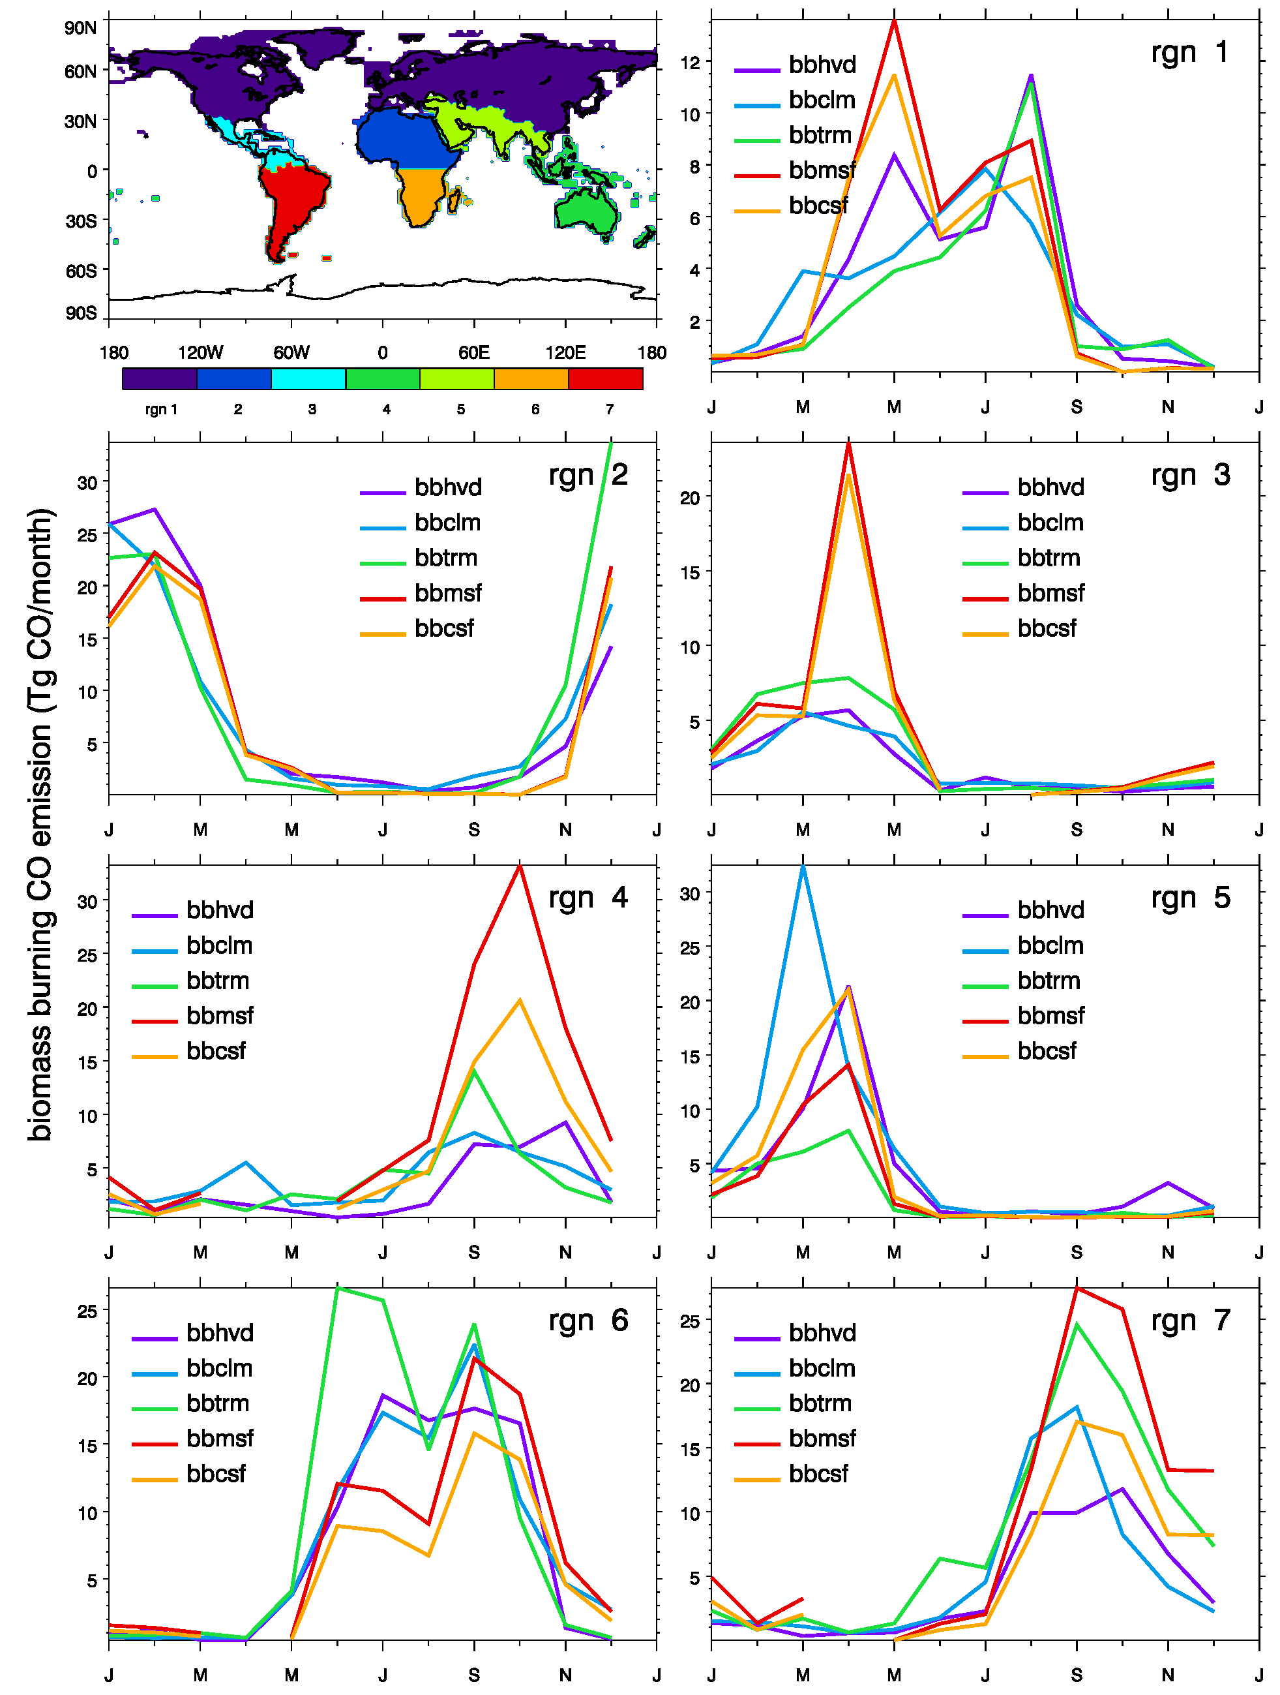
Figure 1. Monthly mean biomass burning emissions from five approaches on seven regions (region 1: northern hemispheric boreal forest; 2: north Africa; 3: central America; 4: south-east Asia and Australia; 5: south-east Asia, India, and middle east; 6: South Africa; 7: South America)

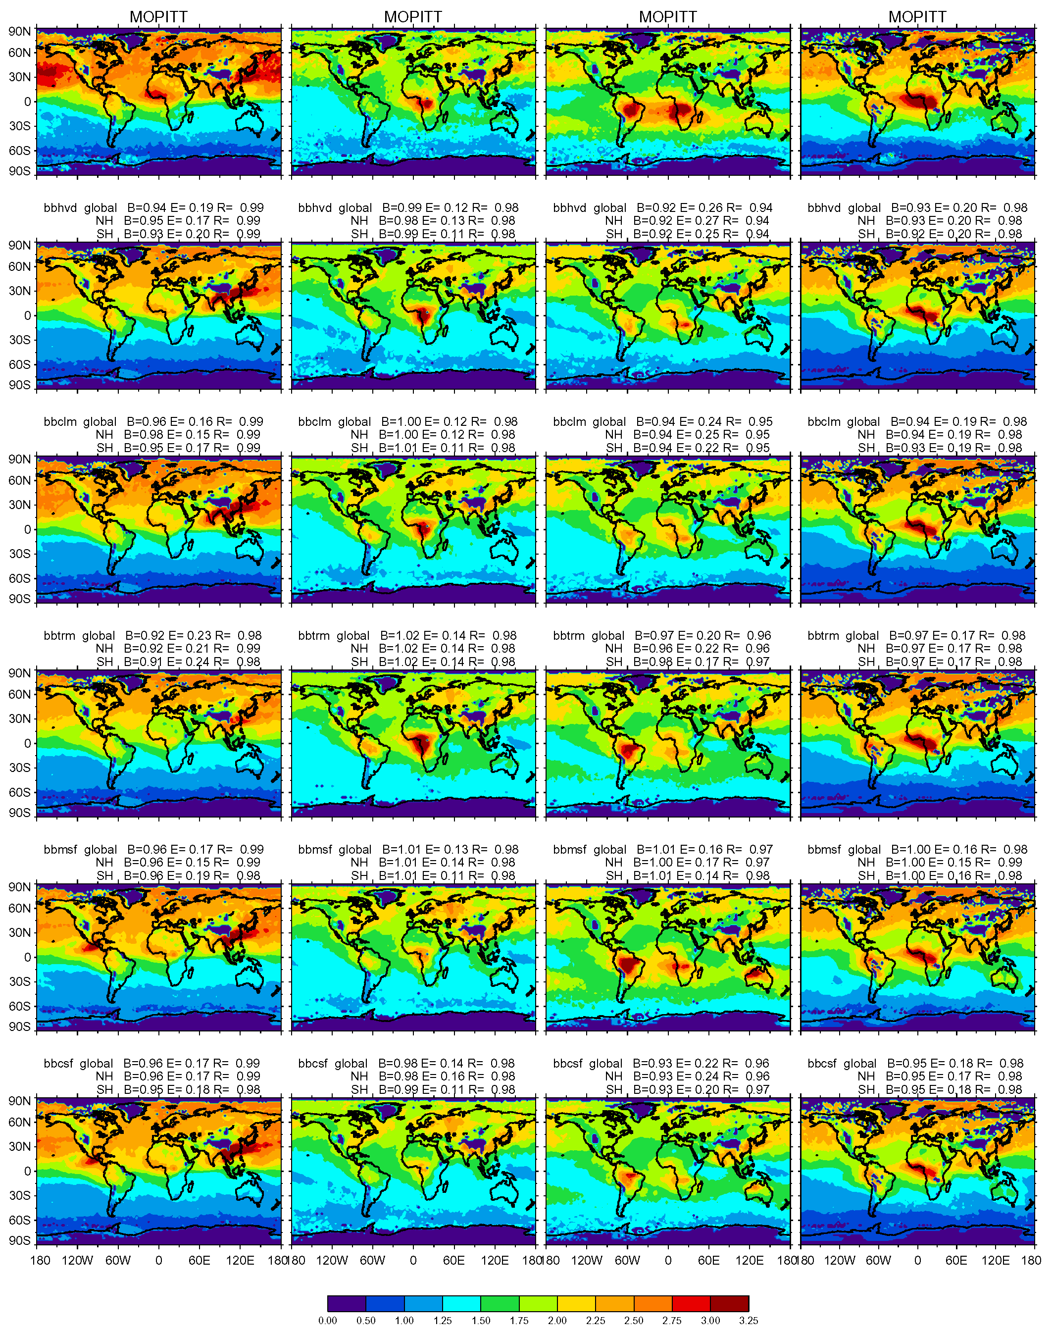
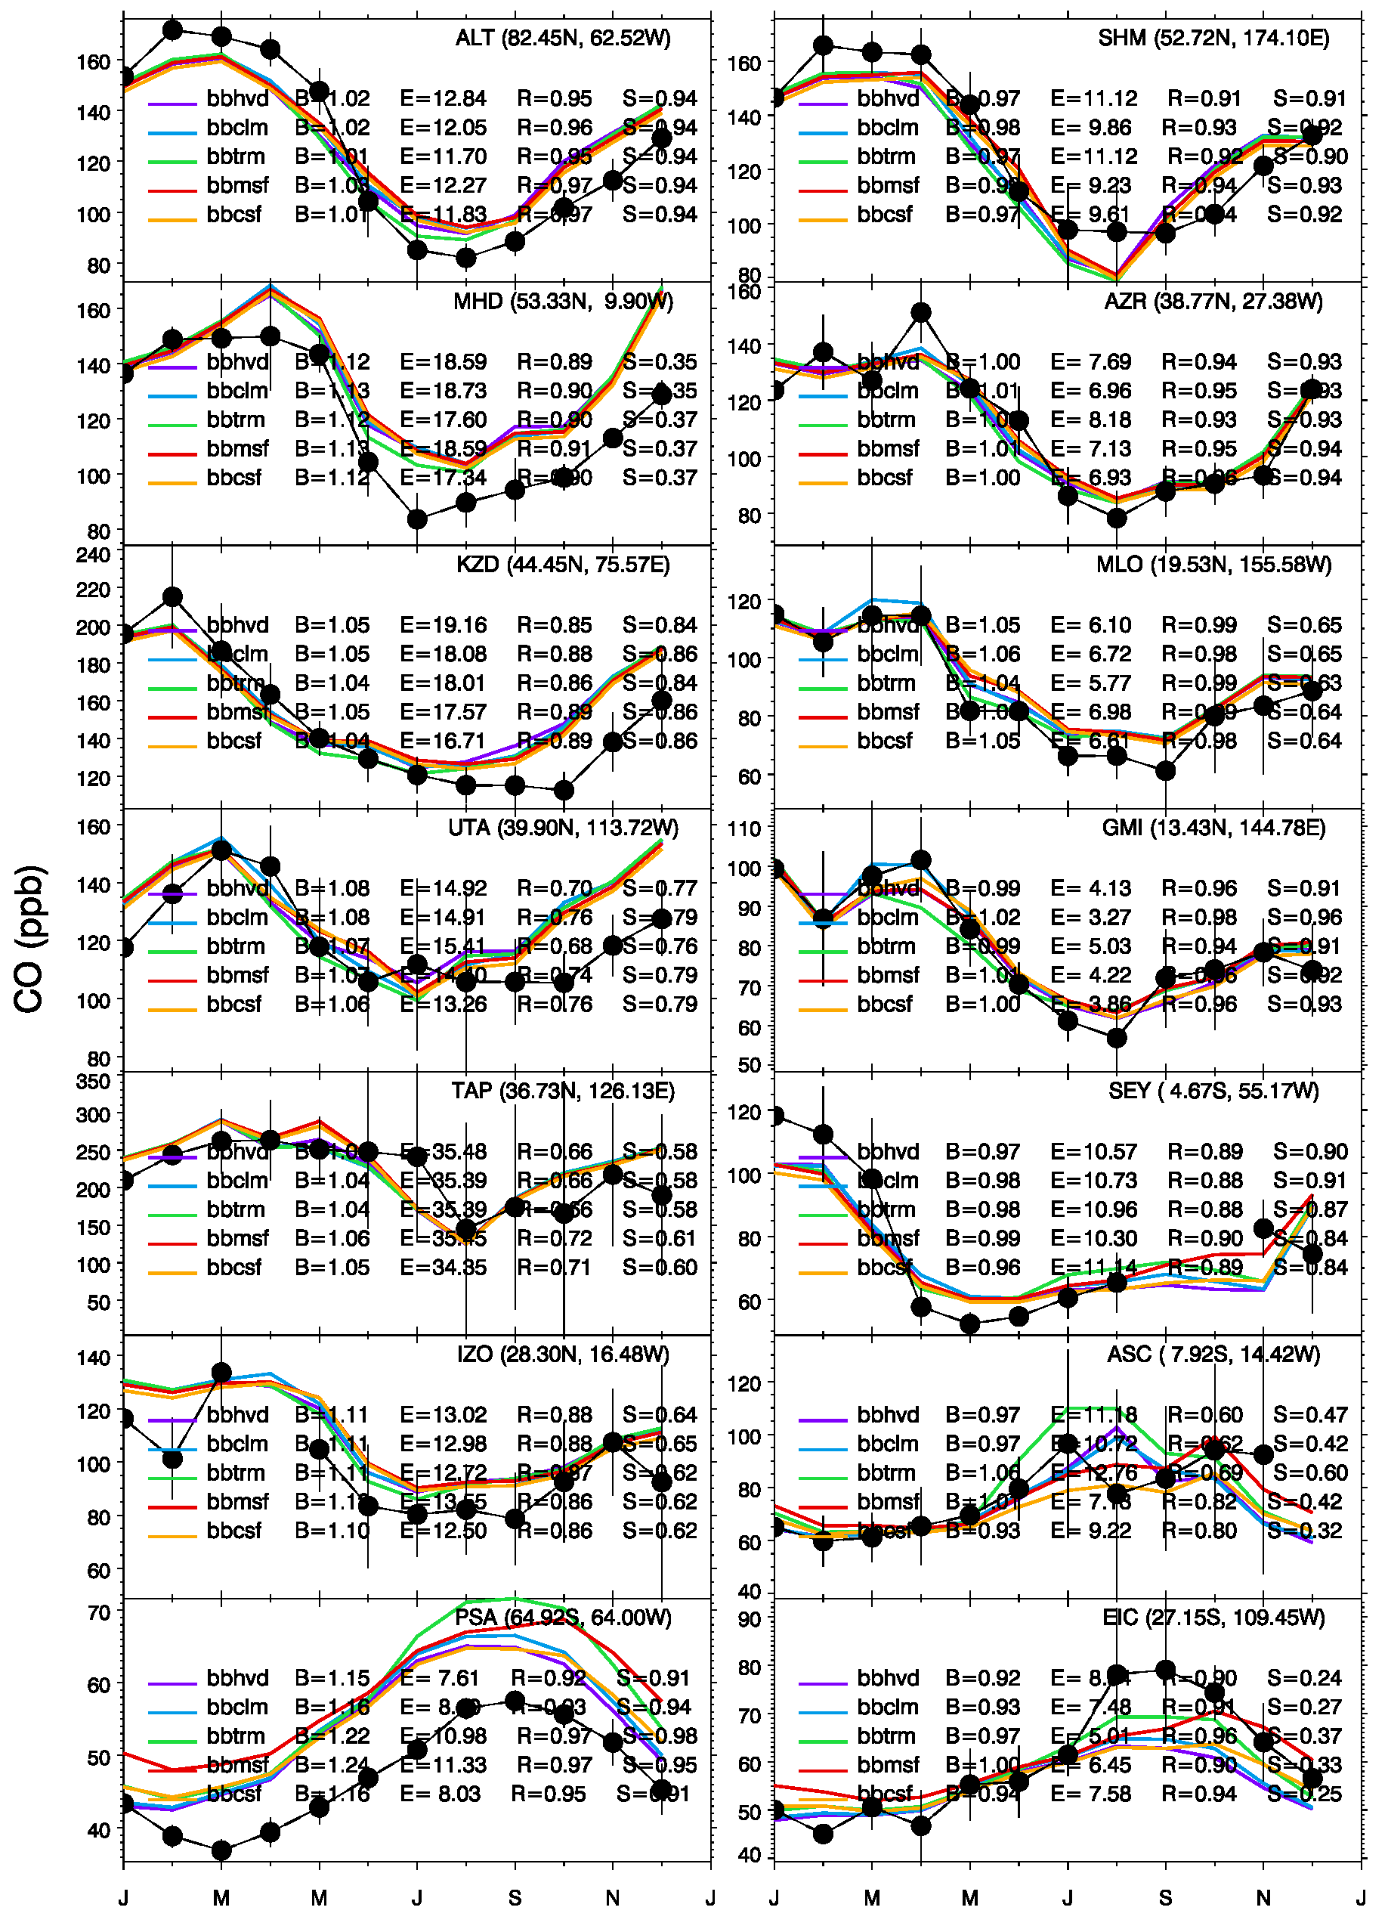
Figure 2. The MOPITT observed and model simulated global column CO distributions for April, July, and October 2000 and January 2001 using different biomass burning emissions. Note that the BB01’s biomass burning emission for January 2001 is repeated its emission of 2000’s.

Figure 3. Surface CO mixing ratio (ppb) model-observation comparisons at land (left) and ocean (right) stations. Dot solid line stands for CO monthly mean from CMDL measurements and solid color lines are from model simulations with standard setting but using different biomass burning emissions (see Table 1). Quantitative estimations are given using statistical parameters of mean bias (B: represents the ratio of the model results to the data); the root mean square error (E: reveals the magnitude of absolute difference between the model and observations); the correlation coefficient (R: measures the linear correspondence); and the skill score (S: considers both correlation and standard deviation between model and measurement).

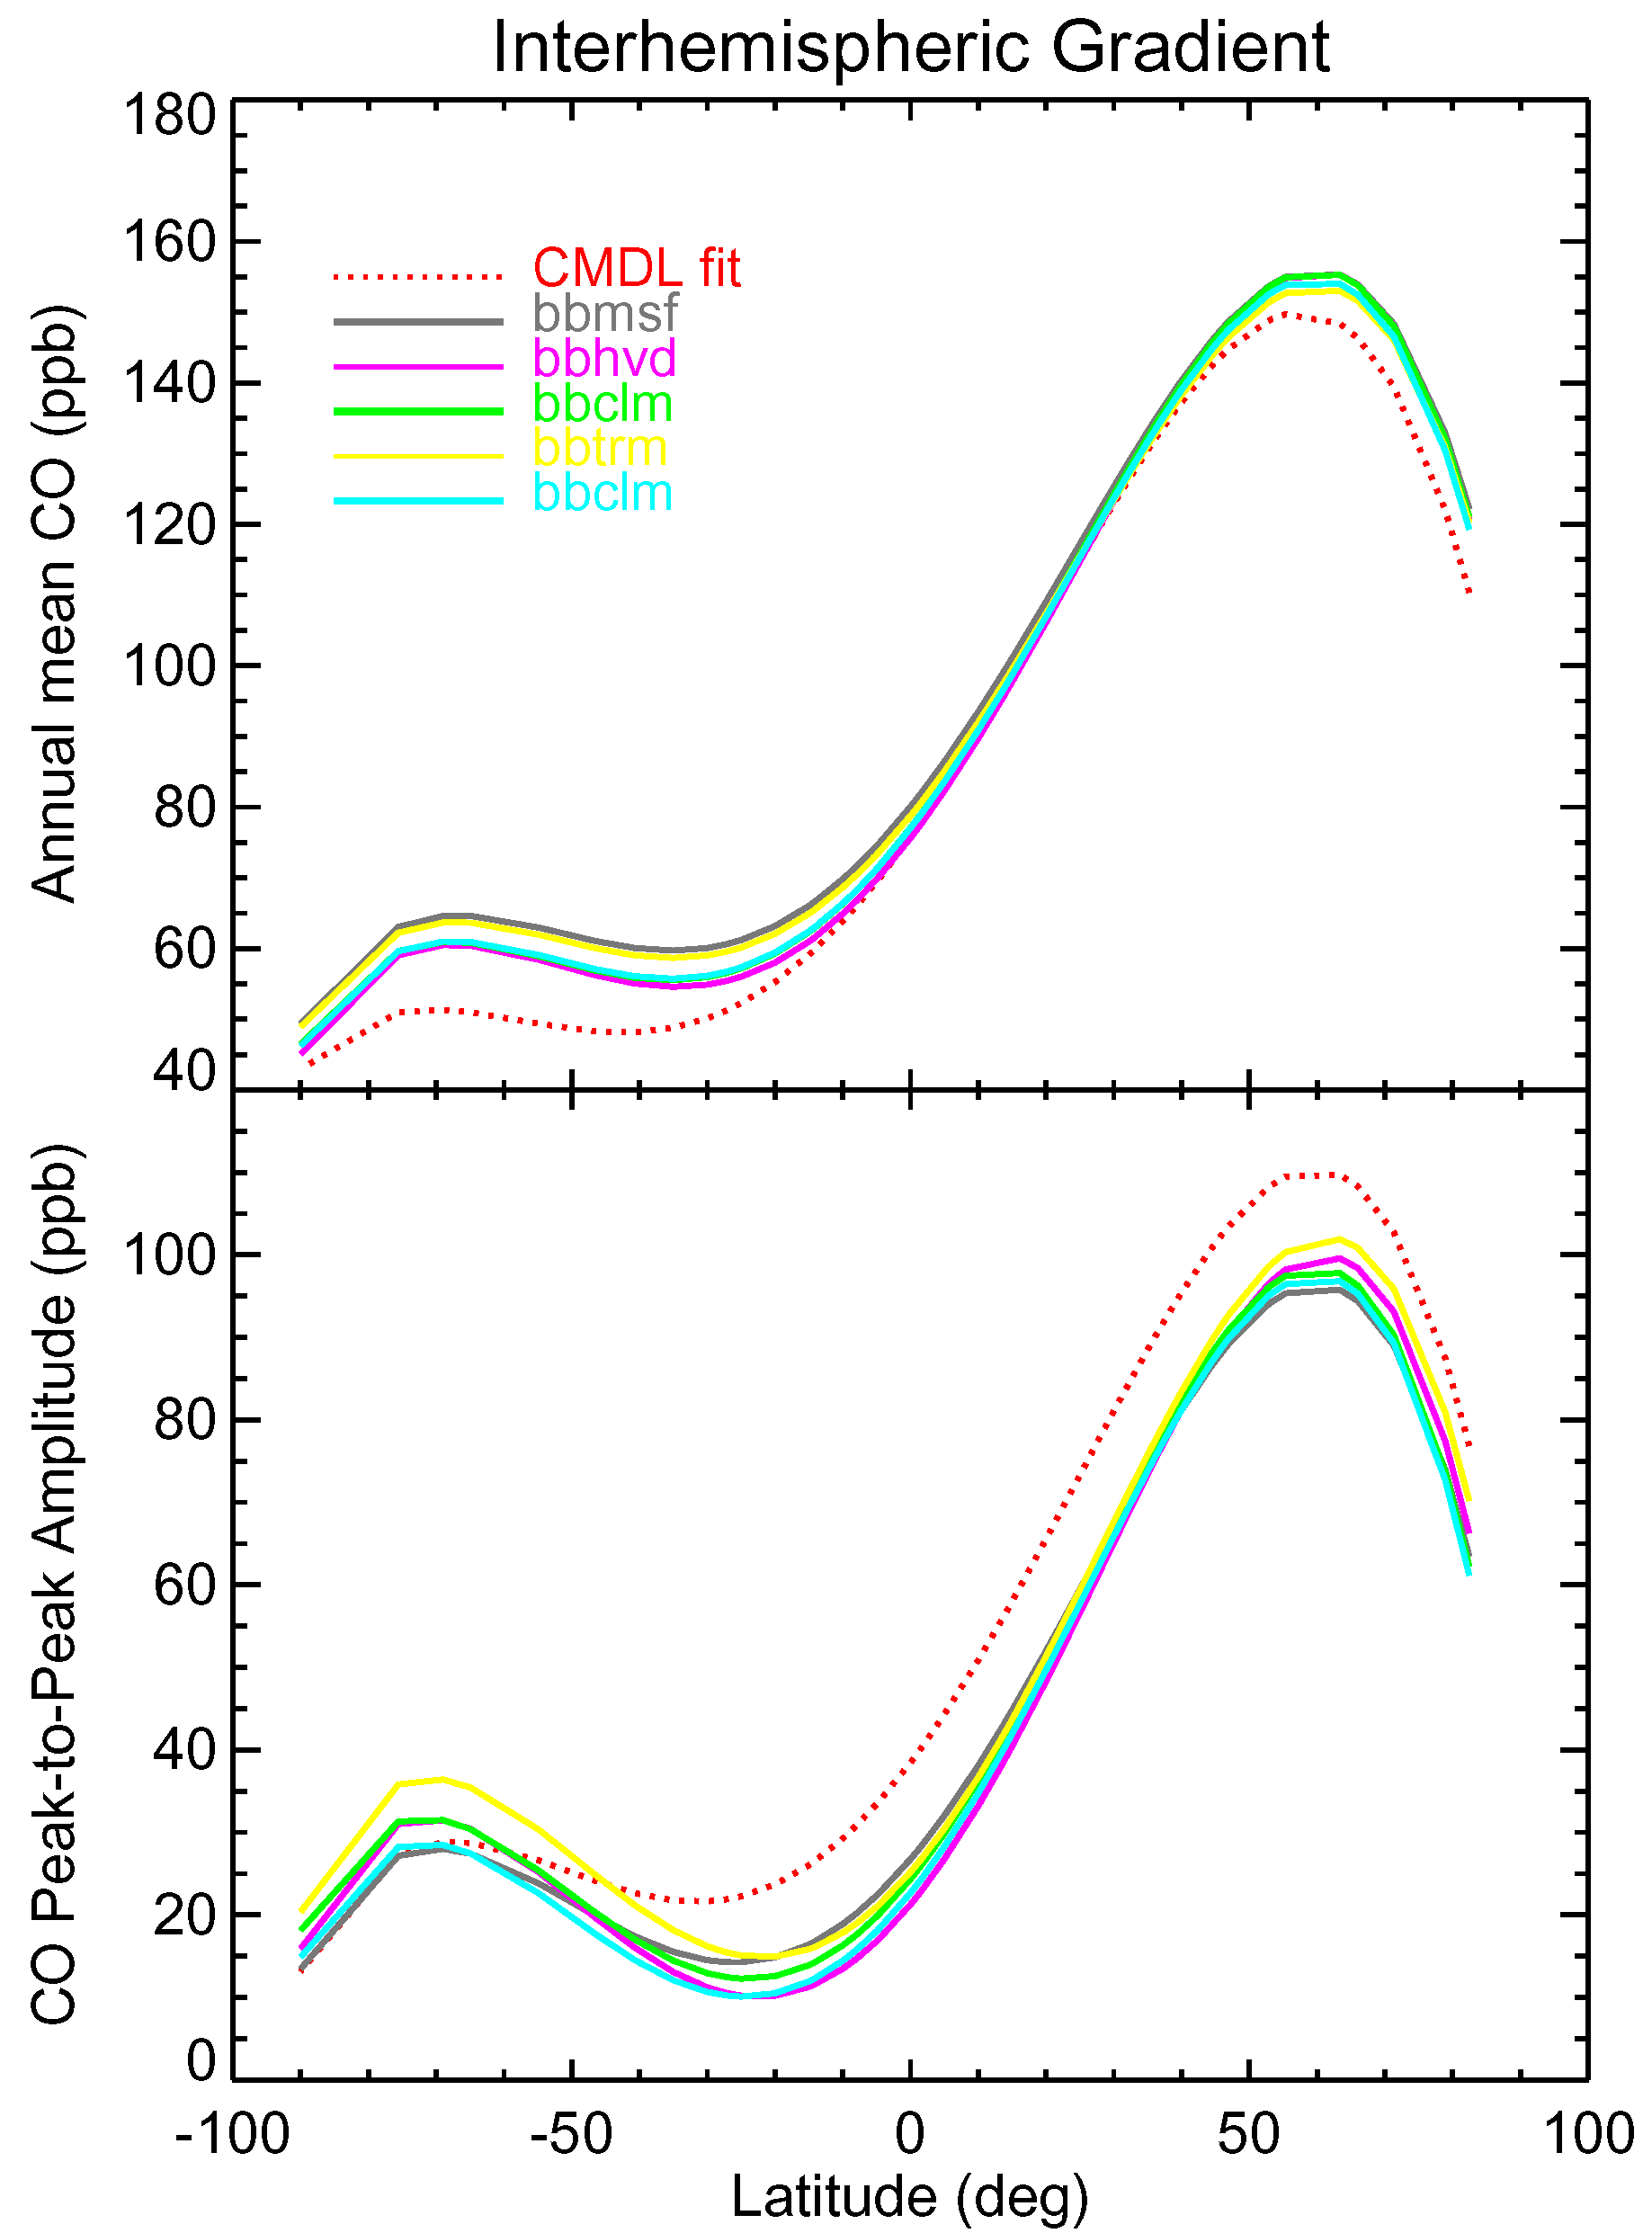
Figure 4. Upper panel: comparison of the annual mean latitude gradients of atmospheric CO from the observations (red) and simulations with different biomass burning emissions: BB01 (purple); BB02 (green); BB03 (yellow); BB04 (grey); and BB05 (blue). Lines are generated using a polynomial fit over latitude of the observations and model sampled to the observation points. Lower panel: amplitude of the seasonal cycle of atmospheric CO as a function of latitudes. The seasonal amplitude is calculated from the peak-to-peak difference in the monthly mean time series.

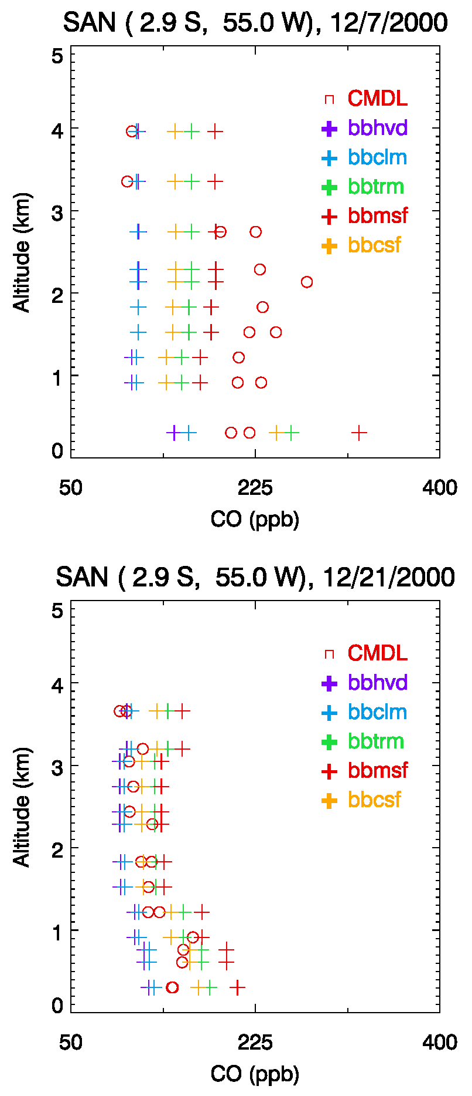
Figure 5. Real time vertical CO mixing ratio comparisons between model simulations with different biomass burning inventories and CMDL aircraft measurements at station SAN in December 7, 2000 (upper panel) and December 21, 2000 (lower panel).

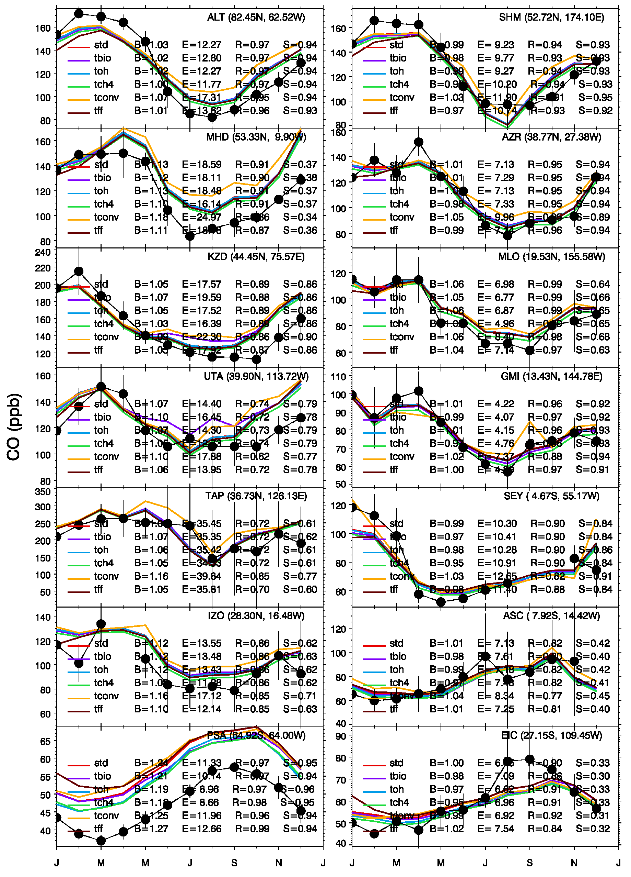
Figure 6. Same as Figure 3 but for the other procedures in emission, chemistry, and transport [see Table 1].

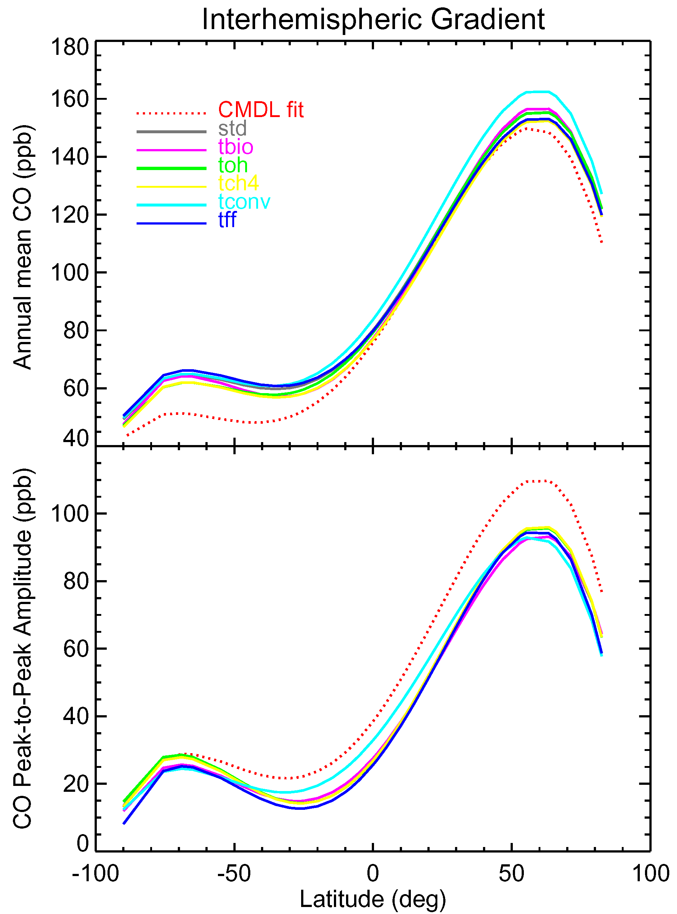
Figure 7. Same as Figure 4 but for the other procedures in emission, chemistry, and transport [see Table 1].

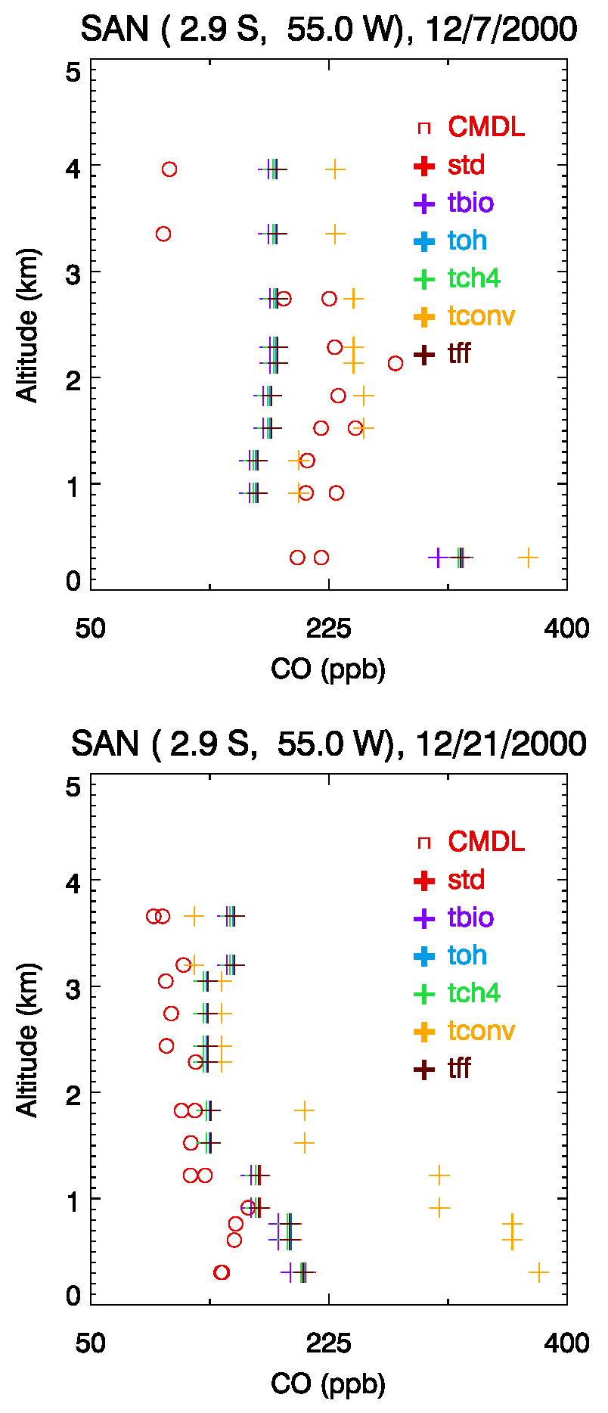
Figure 8. Same as Figure 5 except tested for the other processes for emissions, chemistry, and transport [see Table 1].

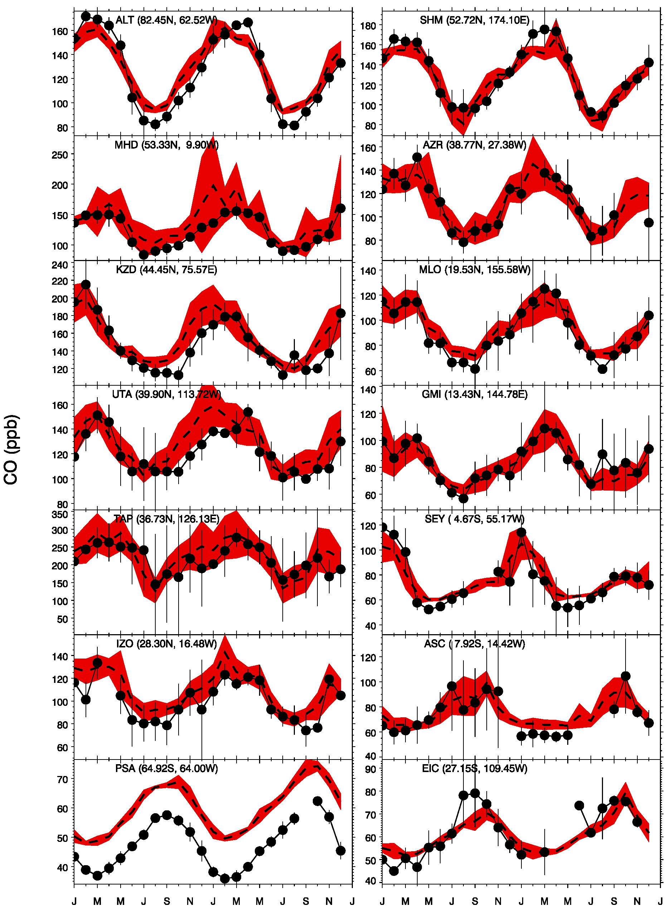
Figure 9. Comparisons of measured (black circles) and calculated (thick dash line) seasonal cycles over two year period (2000 – 2001) of CO concentrations (ppb) at CMDL land (right) and ocean (left) sites. Standard deviations of the daily value are shown in vertical thin black lines for the measurements and in read shades for the model. Simulations are set up with the standard conditions in Table 1.

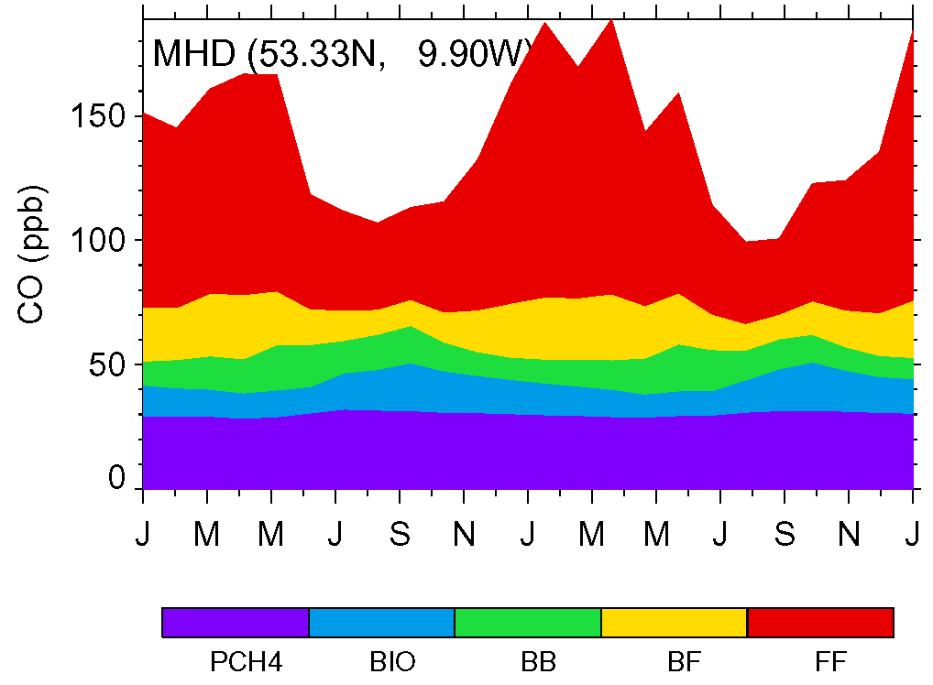
Figure 10. Tagged CO simulation for the year 2000 to 2001 at Mace Head, Ireland. Tagged CO includes fossil fuel, biofuel, biomass burning, biosphere, and methane oxidation. Simulations are set up with the standard conditions in Table 1.

