Figure S1, Part A. Comparative gene arrangement on Roseobacter chromosomes.

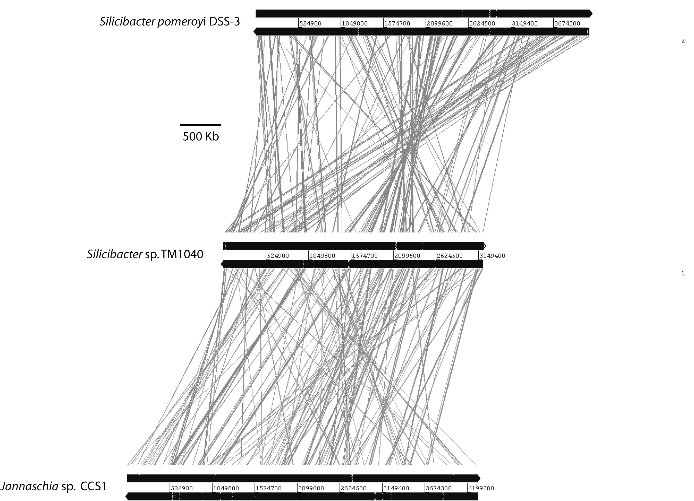
Figure S1, Part B. Comparative gene arrangement on Roseobacter megaplasmids.
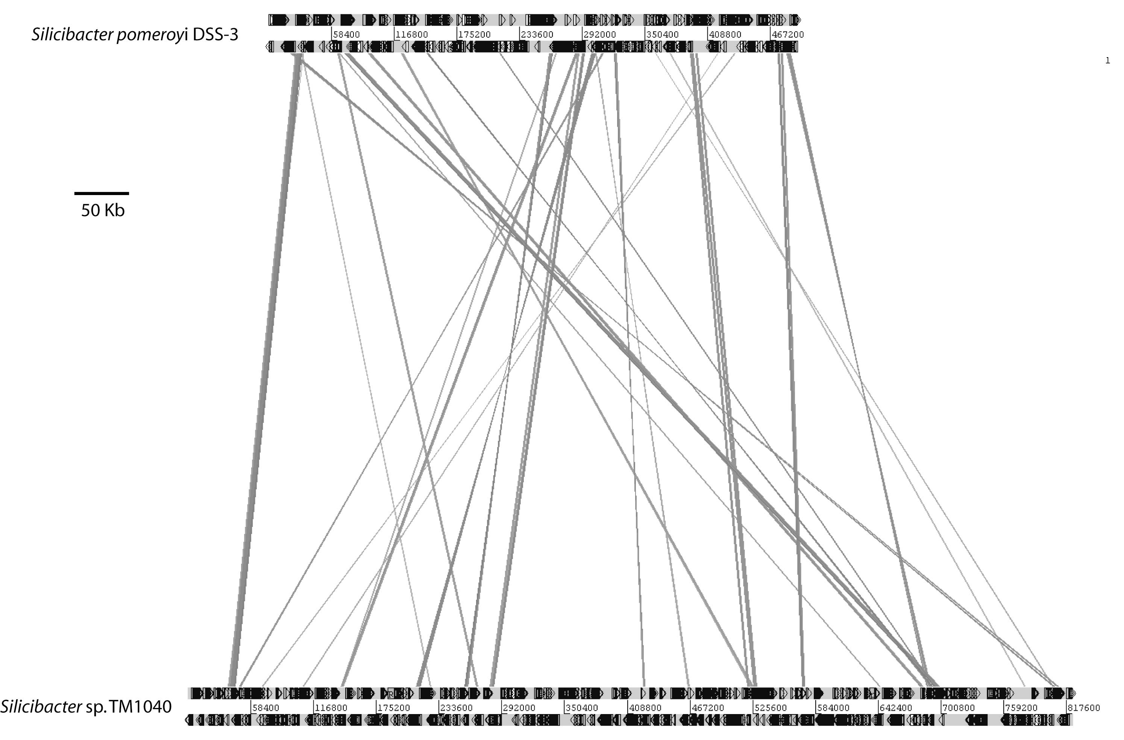
Figure S1, Part C. Comparative gene arrangement on Roseobacter plasmids pSTM2 and pJCS1 shows only 9 genes are similar. The ORFs on pSTM2 have highest similarities to α and γ−Proteobacteria genes (only 8% have best matches outside these taxa), while ORFs on pJCS1 have highest similarities to genes from more diverse organisms including δ−Proteobacteria (16%), β−Proteobacteria (8%), and Cyanobacteria (8%).

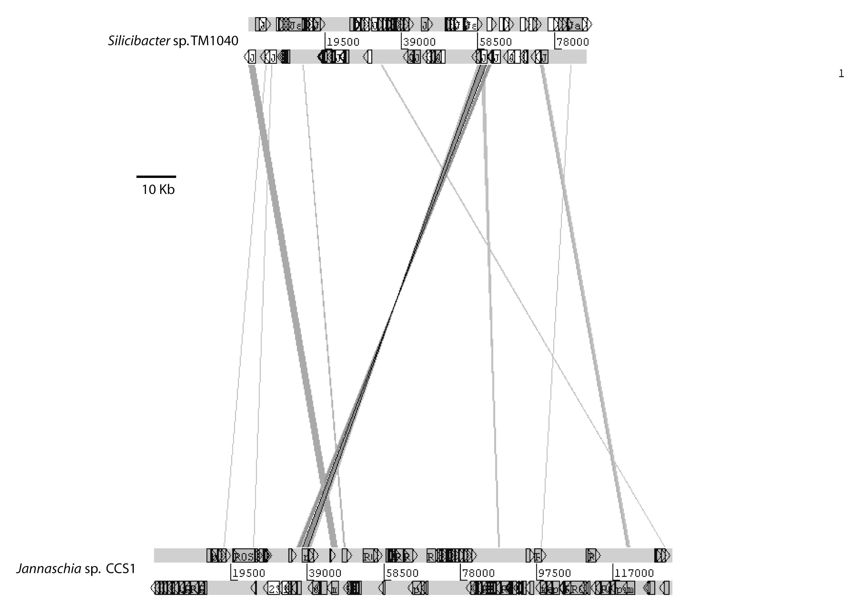
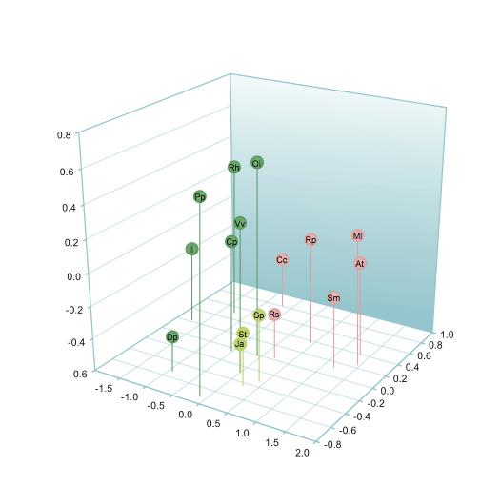
Figure S2. Multidimensional scaling plot of transporter families of roseobacters (light green), other nonmarine α−Proteobacteria (pink), and other marine heterotrophs (dark green). Organism codes are as follows: Ja=Jannaschia sp. CCS1; St=Silicibacter sp. TM1040; Sp=Silicibacter pomeroyi; Rs= Rhodobacter sphaeroides ATCC17025; Sm= Sinorhizobium meliloti 1021; At= Agrobacterium tumefaciens C58; Ml= Mesorhizobium loti MAFF303099; Rp= Rhodopseudomonas palustris CGA009; Cc= Caulobacter crescentus CB15; Vv=Vibrio vulnificus CMCP6, Dp=Desulfotalea psychrophila LSv54, Oi=Oceanobacillus iheyensis HTE831, Rh=Rhodopirellula sp. 1, Cp=Colwellia psychroerythraea, Pp=Photobacterium profundum, and Il=Idiomarina loihiensis. The plot is based on distances from a Bray-Curtis similarity matrix of 70 transporter families. Stress value = 0.05. Analysis was performed with the PRIMER 5 for Windows software (PRIMERE Ltd, Plymouth, UK).

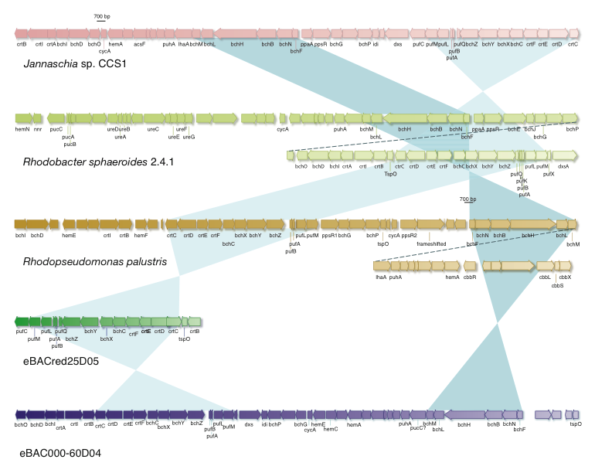
Figure S3. Photosynthetic gene clusters of Jannaschia sp. CCS1, other cultured anoxygenic phototrophs, and environmental BAC clones eBAC00060D04 (O. Béjà, M. T. Suzuki, J. F. Heidelberg, W. C. Nelson, C. M. Preston, et al., Nature 415:630–633, 2002) and eBACred25D05 (A. Oz, G. Sabehi, M. Koblizek, R. Massana, and O. Béjà, Appl. Environ. Microbiol. 71:344–353, 2005).

