Figure S4. Use of ammonium and urea, but not nitrate, as a source of nitrogen by S. pomeroyi DSS-3. Log-phase cultures were transferred from a rich medium to a glucose minimal medium at time 0, and growth was followed as optical density changes in the presence of various nitrogen sources or no nitrogen. Only carry-over growth was observed in the no nitrogen control and with nitrate addition. n=3, +1 S.D. Most error bars are smaller than the symbol.

Figure S5. Use of inorganic phosphorus and phosphonate as a source of phosphorus by S. pomeroyi DSS-3. Log-phase cultures were transferred from a rich medium to a glucose minimal medium at time 0, and growth was followed as optical density changes in the presence of inorganic P (K₂HPO₄), 2-aminoethylphosphonic acid (AEP), or no phosphorus. Carry-over growth observed in the no phosphorus control was subtracted from the treatments. n=3, +1 S.D. Most error bars are smaller than the symbol.

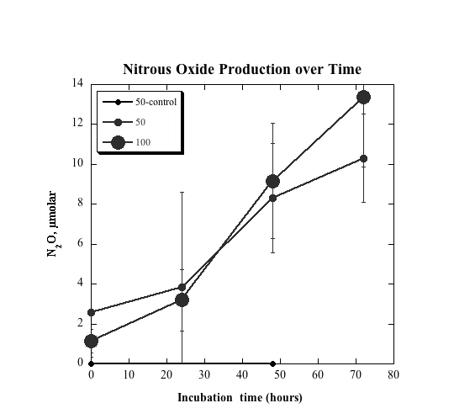

Figure S6. Denitrification by S. pomeroyi DSS-3. Log-phase cultures were purged with argon to remove O₂ and provided with 50 or 100 μM NO₂. Production of N₂O was followed by gas chromatography with quantification by electron capture (S. Joye and H. W. Pearl, Mar. Biol. 119:285–295, 1994). No N₂O was observed in heat-killed controls. No N₂O was observed if NO₃ was provided to the cultures, confirming genomic evidence that the dentirification pathway is incomplete (data from S. Joye and M. A. Moran, unpublished).

