Any Town Fire Department

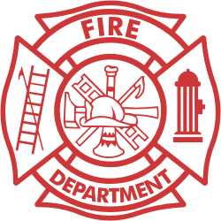

Emergency Medical Service

Swine Flu Policy

Background information: as of April 29, 2009

Swine Flu, also known as A-(H1N1) flu, is a new strain of flu which has no naturally occurring immunity in the human population. There is no vaccine available yet. Because of this it is highly contagious and may result in illness or death in some contaminated individuals. Isolated outbreaks of disease are known as epidemics.

An influenza pandemic occurs when a new influenza virus emerges for which there is little or no immunity in the human population. The virus begins to cause serious illness, and then spreads easily from person to person worldwide. According to the U.S. Department of Health and Human Services, Swine influenza, also known as A-(H1N1), has been diagnosed in patients in California, Texas, Kansas, New York City, Ohio, and Mexico. The list is changing and growing daily. There are eight confirmed cases of swine influenza A-(H1N1) in a private school in Queens. All patients are reported to have fully recovered. It is important to remember that the majority of people who become infected with A-H1N1 are not going to die! The majority will recover with routine medical care of their symptoms. Universal precautions, including proper training, fit testing and appropriate use of an N-95 face mask along with proper hand washing, will protect you!

